

CONSULTANCY SERVICES TO VERIFY AND RECORD ASSETS UNDER THE UGIFT PROGRAMME

REF: MOFPED/UGIFT/CONS/25/26/00015

ASSET VERIFICATION REPORT

SUBMITTED BY:

Plot 31, Bukoto Street
P.O Box 7657, Kampala, Uganda
+256 (0) 39 2000216/0772525235
email: cpa@cpa.ug
www.cpa.com

September 2026

Table of Contents
Executive summary 4
1 Introduction and background 5
1.1 Introduction 5
1.2 Background to the verification 5
1.3 Justification 7
1.4 Objectives of the assignment 7
1.5 Scope of Work 7
1.6 Expected deliverables 7
2 Approach and methodology 8
2.1 Preparation: 8
2.2 Data collection 8
2.3 Quality assurance 9
2.4 Asset categories, condition, use and identification 9
2.5 Financial analysis and Valuation 9
2.6 Analysis and reporting 9
2.7 Challenges and Limitations to the assignment 9
3 Findings 11
3.1 Overall results 11
3.2 National level Ministries and Agencies results 18
3.3 MDA specific results 19
3.3.1 Ministry of Finance, Planning and Economic Development 19
3.3.2 Ministry of Works and Transport 19
3.3.3 Ministry of Education and Sports 20
3.3.4 Ministry of Agriculture, Animal Industry and Fisheries 21
3.3.5 Ministry of Health 22
3.3.6 Office of the Prime Minister 23
3.3.7 Office of the Prime Minister 24
1.1.1 Ministry of Water and Environment 24
3.3.8 Ministry of Gender, Labour and Social Development 25
1.1.1 National Environment Management Authority 25
1.1.2 Public Procurement and Disposal of Public Assets Authority 26
1.2 Office of the Auditor General (OAG) 27
1.2.1 Ministry of Local Government 27
1.2.2 Ministry of Lands, Housing and Urban Development 28
1.3 Results from blood banks 30
1.4 Local Government level results 31
1.5 Health Centres 32
1.5.1 Availability of the assets 32
1.5.2 Asset condition and functionality 32
1.5.3 Asset marking and Identification 34
1.6 Seed Secondary Schools 35
1.6.1 Availability of the assets 35
1.6.2 Asset condition and functionality 36
1.6.3 Asset marking and Identification 36
1.7 Field Observations, 40
1.7.1 Location and Name changes 40
3.7 UgIFT support to service delivery 42
3.7.2 Gaps and Challenges 42
2 Asset management 44
2.1 Maintenance and repairs 44
3 Recommendations 47
4 Annexures 50

List of acronyms
DLI
GOU Government of Uganda
GPS
HC Health centre
ICT Information and communications technology
IDA
IGFT
IGFT RP
HC
IFMIS Integrated Financial Management Information System
KCCA Kampala Capital City Authority
LG
LGFC Local Government Finance Commission
MAAIF Ministry of Agriculture, Animal Industry and Fisheries
MDA Ministry, Department and Agency
MDALGs
MF
MoDVA Ministry of Defence and Veteran Affairs
MoES Ministry of Education and Sports
MOES Ministry of Education and Sports (as engraved)
MoFPED Ministry of Finance, Planning and Economic Development
MoGLSD Ministry of Gender, Labour and Social Development
MoH Ministry of Health
MOH Ministry of Health (as engraved)
MoLG Ministry of Local Government
MoLHUD Ministry of Lands, Housing and Urban Development
MoPS Ministry of Public Service
MoWE Ministry of Water and Environment
MoWT Ministry of Works and Transport
NDP
NEMA National Environment Management Authority
OAG Office of the Auditor General
OPM Office of the Prime Minister
PFM
PforR Program-for-Results
PPDA Public Procurement and Disposal of Public Assets Authority
RA’s
RCU Reform Coordination Unit
RHD
TELA Teacher Effectiveness and Learner Assessment
UBTS Uganda Blood Transfusion Services
UgIFT Uganda Intergovernmental Fiscal Transfer
UGX Uganda shillings
UPS Uninterruptible power supply

Executive summary

Introduction and background

Introduction
This report presents the findings of the UgIFT asset verification undertaken by the Ministry of Finance, Planning and Economic Development as part of programme closure activities. It sets out the status of the assets provided by the programme to the targeted national and local government institutions responsible for supporting the implementation of the programme. Blood Banks and local governments specifically targeting seed secondary schools and health facilities upgraded from Health Centre II to Health Centre III.

Background to the verification

The Uganda Intergovernmental Fiscal Transfers (UgIFT) Programme is a government programme implemented through a Programme-for-Results (PforR) instrument launched and aligned with the broader IGFT Reform Programme (2015). UgIFT 1.0 began with US$200 million in FY2017/18, supporting Education and Health. This was later expanded through additional financing of US$300 million, including US$240 million in credit and US$60 million in grants, with US$50 million from the IDA Refugee Support Window, expanding beyond Education and Health to Water and Environment and Agriculture (micro-scale irrigation) making the overall funding total of US$500 million.

The Intergovernmental Fiscal Transfer Reform Programme (IGFT RP) was revised in 2020 to align with the Third National Development Plan (NDP III 2020/21 - 2024/25), and to directly contribute to Four (04) Programmes i.e. Human Capital Development; Public Sector Transformation; Natural Resources, Environment, Climate Change, Land and Water Management; and Development Plan Implementation.

Overall, the development objective of the UgIFT Programme was to: “Improve the adequacy, equity, and effectiveness of financing and the oversight, management, and delivery of Local Government services in Education, Health, Water and Environment, and Agriculture (micro-scale irrigation), including refugees and their host communities”.

Specifically, the Programme sought to:
- Increase the adequacy and predictability of fiscal transfers to Local Governments for service delivery;
- Improve the equity and transparency of allocation mechanisms through the introduction of formula-based transfers;
- Strengthen performance incentives and accountability systems for Local Governments; and
- Expand access to quality education and health infrastructure, particularly in under-served areas.

The UgIFT Programme had four components aimed at strengthening the intergovernmental fiscal transfer system while supporting investments in service delivery infrastructure. These included;

Component 1: Reform of the Intergovernmental Fiscal Transfer System
This supported the design and implementation of a reformed fiscal transfer framework based on objective and transparent allocation criteria. This resulted into introduction of formula-based grants - Revised allocation formulas reflecting population, infrastructure gaps, and service delivery needs.

Component 2: Education Infrastructure Development
This component financed the construction and upgrading of education facilities, particularly government secondary schools in under-served sub-counties. This involved construction and equipping of new secondary schools - classrooms, laboratories, administration blocks, sanitation facilities, teachers’ houses, furniture and ICT equipment in the local governments.
Component 3: Health Infrastructure Development
This supported investments in health facilities to improve access to primary health care services at the local level. The major outputs under the component were construction and upgrading of health centers - Staff accommodation, sanitation facilities and provision of medical equipment.

Component 4: Local Government Performance and Institutional Strengthening
This aimed at Strengthening local government capacity in planning, budgeting, procurement, and infrastructure management. Under this component, Annual local government performance assessments have been undertaken across the 176 Local governments, capacity building and technical support strengthened, monitoring and reporting systems across the Local governments improved

The Programme was implemented through a clearly defined results framework that connected actions and incentives across three levels of government to strengthen service delivery outcomes. The programme closed on 31st December 2025. By that time, it had accomplished the following outputs under the different components;

Budget Support
- Education: 196 of 259 Seed Schools are complete and of these 189 are operational.
- Health: 354 of 373 health facility upgrades/new constructions (HC II to HC III) are complete.
- Water and Environment: 758 - piped water systems, 5,398- point water sources, 7,082 water supply systems rehabilitated, 325 designs completed, and 256 sanitation facilities in the targeted service units.
- Agriculture (Micro-scale Irrigation): Over 6,235 irrigation systems were installed (4,843 hectares under irrigation) and 632 irrigation demonstration sites in 135 LGs set up.
- Refugee intervention: 51 primary schools and 35 health facilities in refugee hosting districts (RHD) were transitioned and integrated into the LG service.
- Blood Banks: Regional Blood Banks in Arua and Hoima were completed and commissioned while Soroti Regional Blood Bank was rehabilitated.

- Grant management
Assets for institutional strengthening and retooling including ICT equipment and vehicles were provided. The Ministry of Finance, Planning and Economic Development (MoFPED) through PFM Coordination Unit (RCU) manages the Government of Uganda counterpart funding of the programme to support the grant management component of the UgIFT programme. The grant management supports in financing of Central Government actions intended to achieve programme objectives and Disbursement Linked Indicators (DLIs). To this end, MoFPED through RCU supported MDAs to acquire different assets meant to support programme implementation.

Justification

The UgIFT programme came to an end on 31st December 2025. As part of the programme’s closure activities, MoFPED, through RCU, commissioned an end-of-programme asset verification exercise to take stock of the assets procured under the programme and to establish where those assets were, how they were being used as part of the processes to hand them over to government for sustainability purposes.

Objectives of the assignment
The objective of the assignment was to undertake verification and recording of all assets acquired under the UgIFT Programme. Specifically, the assignment intended to:

- Identify and verify the existence of the assets;
- Verify the assets condition and status: specifically, the condition on functionality, usage/performance and location;
- Assess financial management aspects: residual value of the investments/hardware/tools for purposes of financial reporting for project closure;
- List the assets that are obsolete, unserviceable and require disposal;
- Develop a computerized database of the investment/hardware/tools to facilitate recording of new deployed assets/investments; and
- Undertake PFM Assessment on Asset Management practices (including sustainability, Operations and Maintenance) of the UgIFT implementing LGs.

Scope of Work
The assignment all institutions at National and local government that directly implemented the UgIFT Program from coordination, support and implementation across the country. At the local government level, the study focused on upgraded/improved health facilities and seed secondary schools only as these had received assets upgraded under the programs as a result.
Specifically, the assignment involved the following tasks:
- Verification of the Asset’s Records of targeted ministries departments and agencies and local governments;
- Physical and Functional Verification of assets;
- Data Consolidation for generation of a single data base of assets provided by the Program;
- Generation of an IFMIS ready Asset Register for Integration, and Migration into IFMIS; and
- Review of the UgIFT Asset Management Practices.

Expected deliverables

Key expected outputs of the consultant include:

- Report with the list and current status of assets acquired under the programmes;
- An automated up-to-date assets data base of UgIFT Investments across MDALGs;
(iii) Report on the estimated value of assets under the programme as well as operations and maintenance arrangements;
(iv) IFMIS-Ready Asset Register and Data Migration Report;
(v) Report on functionality of assets relating to systems investments; and
(vi) Report on Assessment of Asset Management Practices, Risks and Recommendations.

Approach and methodology

The verification exercise was conducted using a participatory and consultative process and implemented in three interlinked phases: Preparatory and inception phase, Data collection phase and the report writing phase.

Preparation:

The Inception phase was completed and the inception report was submitted on 18th June 2026 which provided an agreed scope, approach and work plan for the exercise. The team also undertook a pilot test in Wakiso District Local Government, with verification undertaken at Buloba Health Centre III and Sumbwe Seed Secondary School, which helped in the design of data collection tool and the deployment plans.

Data collection

This exercise was undertaken in two phases first at National level and later at the Local Government level.

National level: Physical visits to verify assets provided by the programme at the national-level was completed on the 19th of August 2026. This covered 15 MDAs including; Ministry of Works and Transport (MoWT); Ministry of Education and Sports (MoES); Ministry of Agriculture, Animal Industries and Fisheries (MAAIF); Ministry of Health (MoH); Office of the Prime Minister (OPM); Ministry of Water and Environment (MoWE); Ministry of Gender, Labour and Social Development (MoGLSD); Local Government Finance Commission; National Environment Management Authority (NEMA); Public Procurement and Disposal of Assets Authority (PPDA); Office of the Auditor General (OAG); Ministry of Public Service (MoPs); Ministry of Lands, Housing and Urban Development (MoLHUD); Ministry of Local Government (MoLG) and Ministry of Finance, Planning and Economic Development (MoFPED). Additionally, three Blood Banks of Hoima, Arua and Soroti were covered.

Local Government level: The local government verification covered all UgIFT upgraded/ constructed Health Centres and Seed Secondary Schools in all the 176 LGs. The process began with a training of field teams prior to the actual field verification.

Training of field teams: A total of 85 Research Assistants (RAs) and 7 Regional Supervisors were trained. The training took place from 21st to 23rd August 2026 and physical verification started on the 24th of August 2026 across all the 176 Local governments. During the Asset verification, the RAs visited Seed Secondary Schools, Health Centres and Blood Banks.

Physical verification: This exercise commenced on the 24th of August 2026 and was completed on 17th September 2026. The local government physical verification involved entry meetings with the leadership at the LG headquarters for authorization and review of reports relating to UgiFT assets, key informant interviews with the technical teams especially the Chief Administrative Officers, Finance Officers, District Health Officers and District Education Officers. Thereafter, the RAs proceeded to the facilities for physical verification of the assets.

At local government level, the programme list had 629 facilities: 371 health centres and 258 seed secondary schools. The list recorded 547 facilities (87.0%) as complete and 82 (13.0%) as ongoing. The ongoing works were more common among seed secondary schools (63, or 24.4%) than among health centres (19, or 5.1%).

Quality assurance
Regional supervisors checked daily field activity and reviewed the completed tools. The central technical team carried out spot checks and helped resolve operational questions. Teams compared institutional asset information with the items and explanations provided during visits, while supervisors referred matters requiring clarification to the team leader and field coordinator.

Asset categories, condition, use and identification

Asset categories. Each asset was counted once and assigned to one report category. Health centre assets were grouped as clinical equipment, clinical furniture, maternity ward equipment and health centre ICT equipment. On the other hand, seed secondary school assets were grouped as school furniture, school computers and related equipment and school support equipment. Another category included other ICT equipment, other furniture, vehicles, motorcycles and buildings, which applied to MDAs, Blood Banks and LGs.

Condition and use. Condition and use were reported as recorded for each asset during the verification. A working asset is one recorded as functional and in use. An asset recorded as faulty was reported as not working and not in use. This included assets that were broken down or damaged. An asset that was new and in store was recorded as functional but not in use. Additionally, an asset that was held elsewhere, not yet delivered or awaiting power installation, completion of buildings or trained users, was also recorded as functional but not in use.

Identification. An asset was properly identified if carried a UgIFT programme marking. However, there were other assets that had no UgIFT marking but the officers on the ground identified them as UgIFT assets.

Financial analysis and Valuation
The Government of Uganda Asset Accounting Policies and Guidelines 2023 was used to determine the recorded values, depreciation and net book values.

Analysis and reporting
Analysis and reporting was done through triangulation of the literature from different policy, Planning and Financial documents including: The Government of Uganda Asset Accounting Policies and Guidelines 2023; asset registers; asset records at national and local government levels; physical inspections; discussions with facility managers; photographs and asset counts for each institution.

Challenges and Limitations to the assignment
Difficult terrain and poor physical accessibility of facilities: Physical accessibility presented a significant operational challenge especially for facilities located in areas characterised by difficult terrain and limited transport accessibility such as Bwesumbu HC III, Bwesumbu Seed School, Buhuhira and Kabingo in Kasese District. In addition, accessing facilities within the Island LGs was difficult, time consuming and expensive. In these cases, the teams overshot the anticipated time for data collection.

High transportation cost: Given the national wide coverage, the rising fuel prices led to high field costs. The field teams spent more money than was anticipated. The costs were extra ordinarily higher to reach the island LGs of Kalangala, Buvuma, Mayuge, Namayingo among others. For instance, Kalangala had 3 facilities with long distance on water that required hiring a private boat since it was not a common route to the transporters and outside the ferry schedule. A similar situation was encountered in Buvuma and Namayingo districts.

Poor record keeping: In many LGs and facilities, there were no clear records about the assets delivered under UgIFT. The LGs and the facilities had incomplete or missing UgIFT asset registers which delayed data collection. Subsequently, the teams took longer in such facilities identifying the assets as most of these were not engraved with the UgIFT identifiers while others were not engraved at all. In addition, the field teams encountered situations where some assets could not be physically accessed especially for schools since it was holiday time.

Findings

This section presents results of the verification exercise based on the specific objectives. The results are presented in different results levels indicating availability of assets, asset condition and functionality, asset marking and identification and the financial analysis in each of the subsections.

Overall results
This section provides an overall view of the UgIFT asset status combining both National level agencies, schools and health centres.

- Overall asset availability

Physical verification of all UgIFT assets across the targeted MDAs, beneficiary Blood Banks, Upgraded Health Centres and Seed Secondary Schools indicated a total of 226,280 assets of different categories including Vehicles, Laptops, Printers, Desktop Computers, Projectors, Furniture (desks, chairs, stools), UPS Systems, Digital Phones, Paper Shredders, Mobile Tablets, clinical equipment’s among others.

Overall, the Seed Secondary Schools have the majority of assets 64.2% (145,376) followed by the Health Centres with 28.1% (63,606), the MDAs have 7.4% (16,668). The Blood Banks have the least number of assets at 0.3% (626) as indicated in Figure 1.

Figure 1: Overall distribution of UgIFT Assets
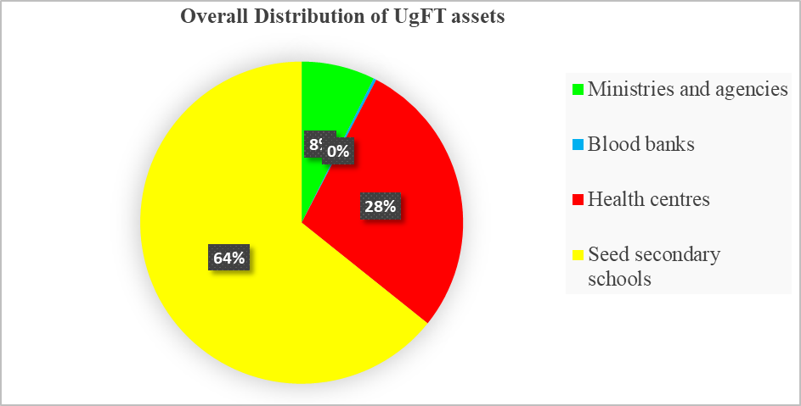
Source: Primary data analysis

- Overall asset Condition and functionality
Overall, 215,879 assets constituting 95.4% were in good condition, 3,392 assets (1.5%) were broken, while 7,009 (3.1%) were not in use. Of all assets in good condition, 94% were in use, while 1.4% were stored and not yet used. The detailed analysis of the overall asset condition is indicated in table 1.

Table 1: Overall condition of UgIFT assets and functionality
Institution | Assets verified | Good condition |  | Broken | Other
Institution | Assets verified | In use | In store | Broken | Other
MoFPED | 458 | 457 | 0 | 0 | 1
MoWT | 88 | 88 | 0 | 0 | 0
MoES | 10,783 | 10,783 | 0 | 0 | 0
MAAIF | 2,045 | 2,045 | 0 | 0 | 0
MoH | 264 | 263 | 0 | 1 | 0
OPM | 10 | 7 | 0 | 3 | 0
MoWE | 2,939 | 2,939 | 0 | 0 | 0
MoGLSD | 10 | 10 | 0 | 0 | 0
NEMA | 6 | 6 | 0 | 0 | 0
PPDA | 5 | 5 | 0 | 0 | 0
OAG | 20 | 20 | 0 | 0 | 0
MoLG | 13 | 13 | 0 | 0 | 0
MoLHUD | 27 | 27 | 0 | 0 | 0
Health centres | 63,606 | 57,921 | 2,629 | 660 | 2,396
Seed secondary schools | 145,376 | 137,585 | 490 | 2,722 | 4,579
Blood banks | 626 | 602 | 0 | 6 | 18
Total | 226,280 | 212,775 | 3,119 | 3,392 | 7,010
Overall proportion |  | 94.03% | 1.38% | 1.50% | 3.10%
Source: Primary data analysis

As indicated in table 1 above, most of the deployed assets were already in use while some were in store and still in good condition but not in use. This was attributed mainly to some localized challenges such as lack of power, incomplete structures, untrained staff, among others. Some assets were broken mainly furniture in Seed Secondary Schools and require repair. Verification also noted that over 7000 assets mainly in seed secondary schools and health centres had not been used because they required installation or the facility itself was not yet ready. Figure 2 presents the reasons for non-deployment of some of the assets even when they were found in good condition.

Figure 2: Reasons for idle or unused assets and equipment
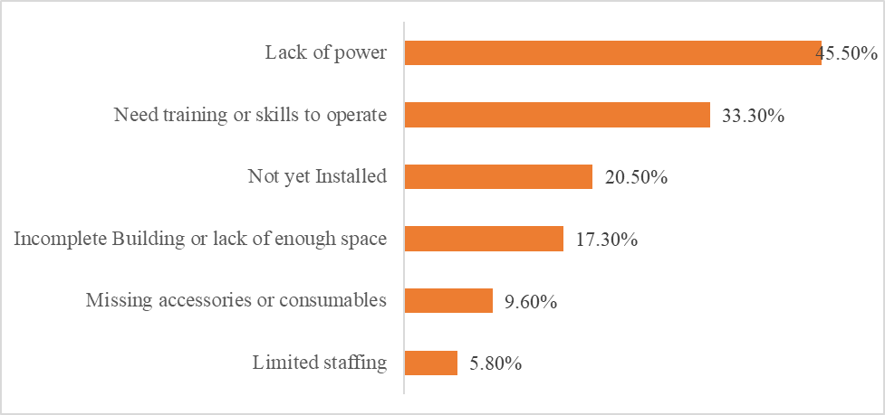
Source: Primary data analysis

Notable among the facilities include Lungulu Seed Secondary School in Nwoya District where desktop computers, a printer and UPS units were still boxed because the school was waiting for power connection. At Nansanga Seed Secondary School in Budaka, 27 of 28 desktop computers remained packed for lack of reliable power. Broken desks and stools were in classrooms and stores at Seed schools in Namisindwa and Napak. At Arua Regional Blood Bank, six blood pressure machines were damaged or not functional. The information above is depicted in some of the photos presented below.

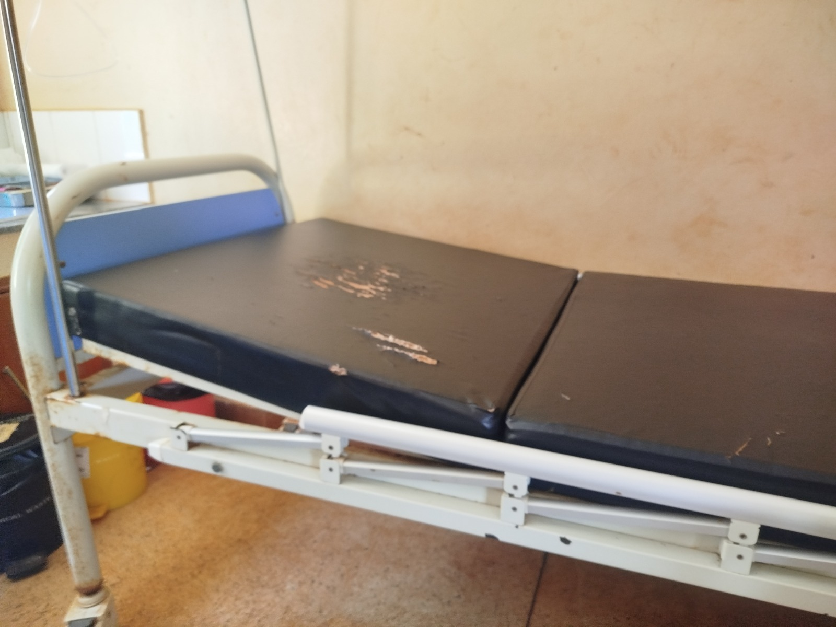 | 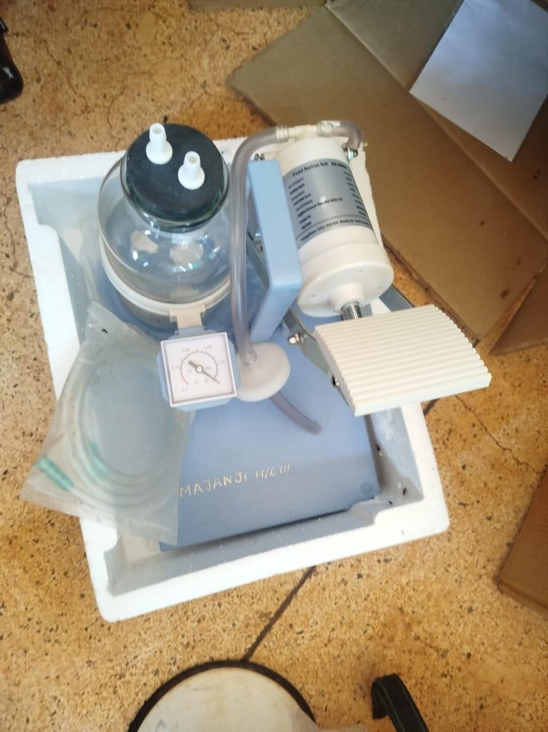
Delivery bed with a torn mattress cover at a health centre in Busia District (Bukedi) | Pedal suction unit marked MAJANJI H/C III- Busia District still in its packing, recorded as not in use for lack of technical knowledge
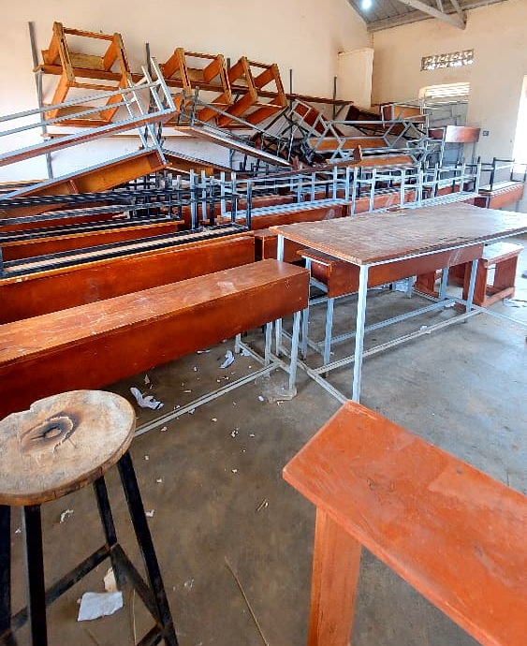 | 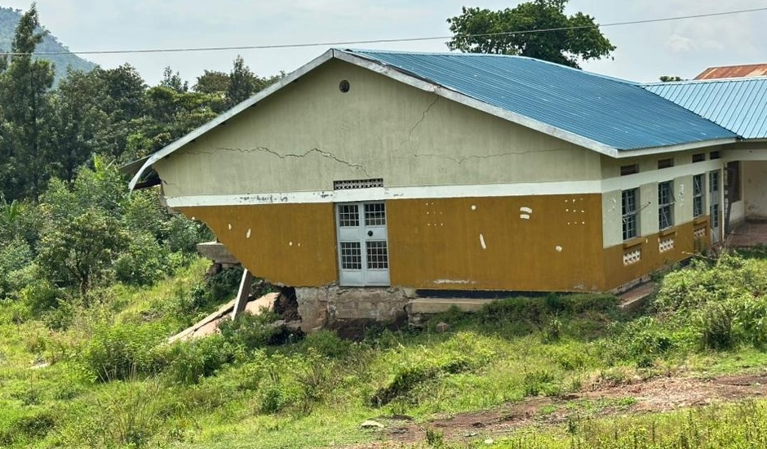
Stacked desks, chairs and stools, some recorded as broken and not engraved, at Napak Seed Secondary School, Napak District (Karamoja) | Cracked health centre block above collapsed ground, Bulambuli District (Bugisu)
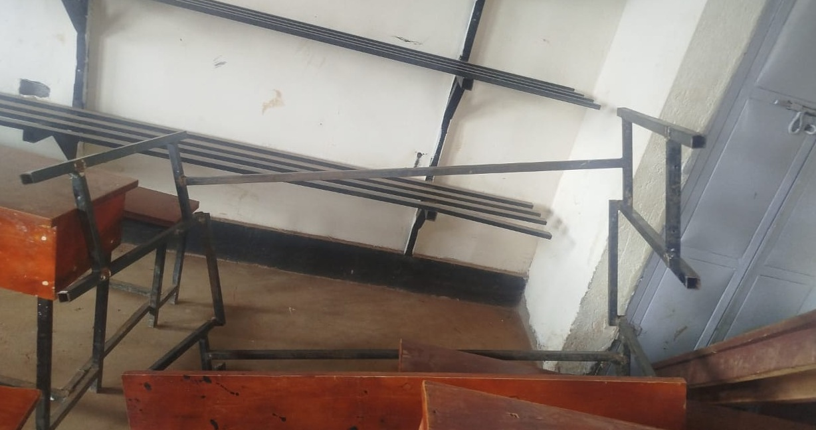 | 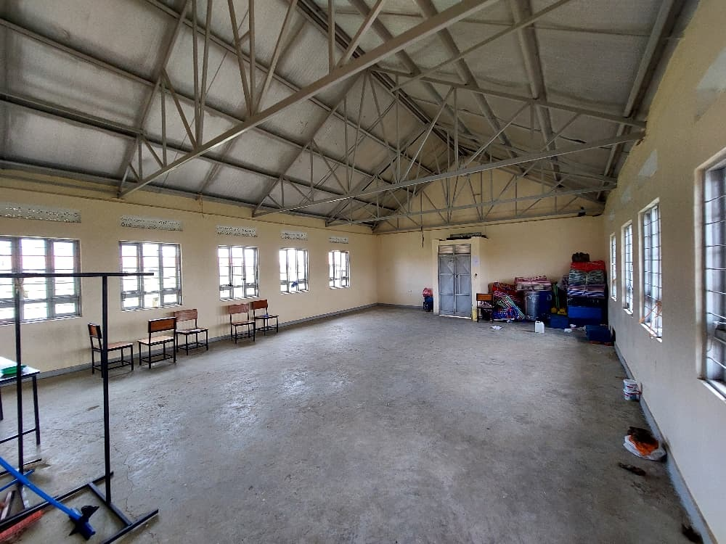
Broken desk frame at a seed secondary school in Namisindwa District (Bugisu) | Empty ICT and library block with a few chairs and items kept in one corner at Iriiri Seed Secondary School, Napak District (Karamoja), not yet in use while the school remained with the contractor
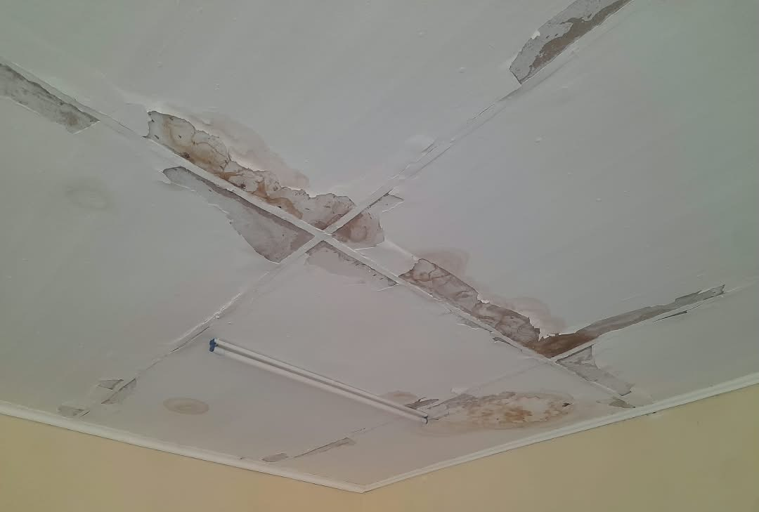 | 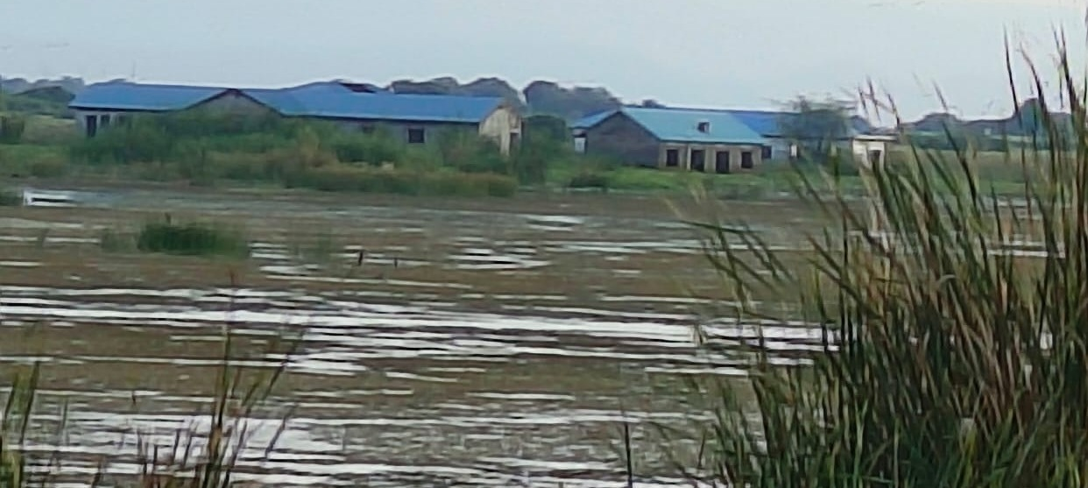
Stained and peeling ceiling at a health centre in Sironko District (Bugisu) | Flood-affected older health facility at Butiaba in Buliisa District (Bunyoro)
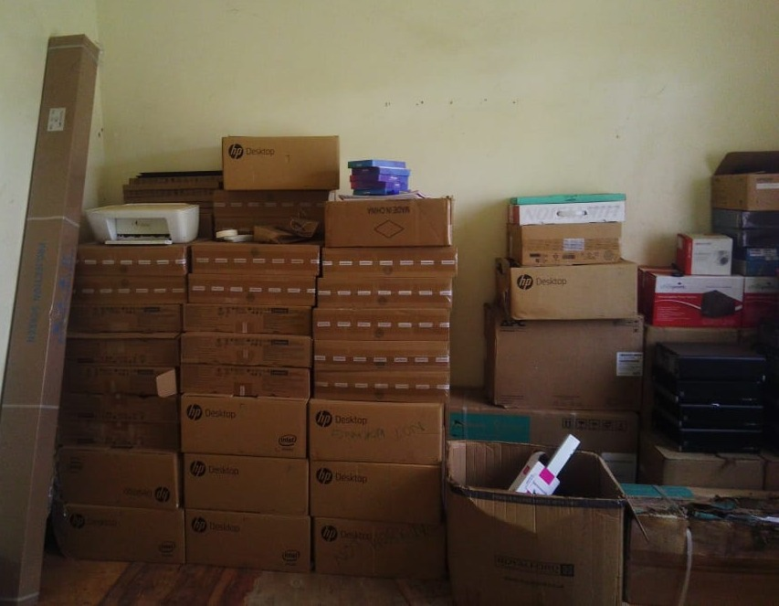 | 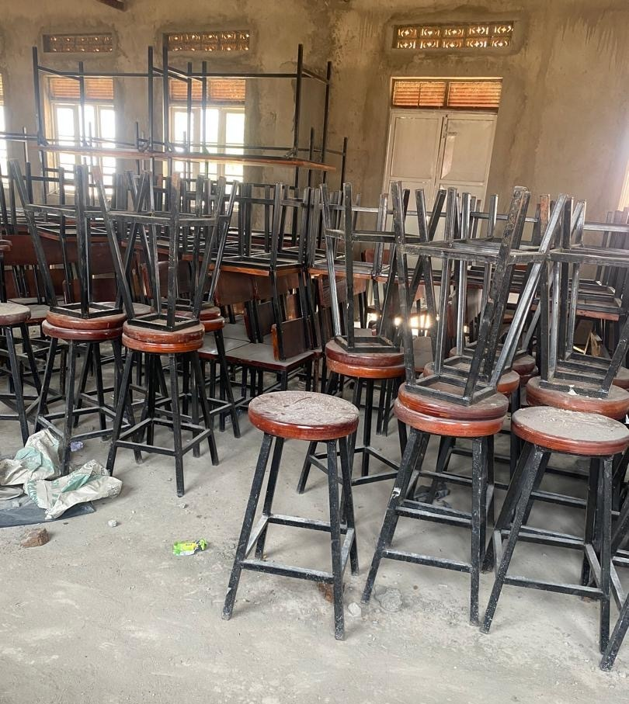
Desktop computers, a printer and UPS units still boxed in the store at Lungulu Seed Secondary School, Nwoya District (Acholi), awaiting power connection | Laboratory stools and desks stored and not yet in use at Butungama Seed Secondary School, Ntoroko District (Tooro), where the school buildings were still under construction
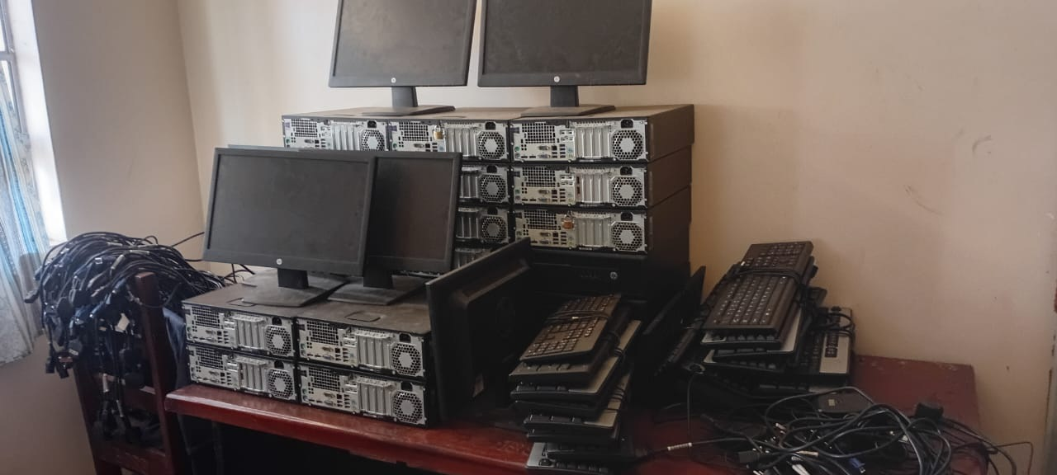 | 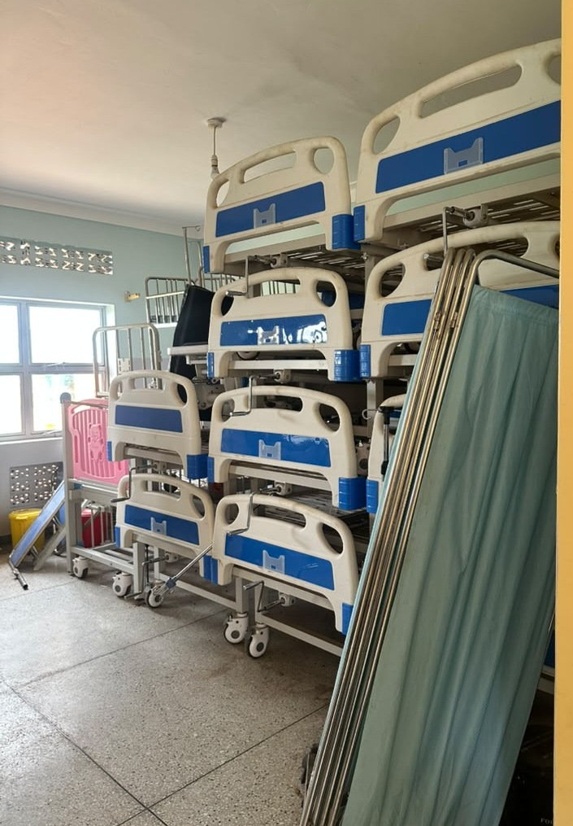
HP computer sets stacked in store with cables still bundled and not installed at Bumufuni Seed Secondary School in Bulambuli District (Bugisu) | Beds and screens stacked in storage at a health centre in Kagadi District (Bunyoro)
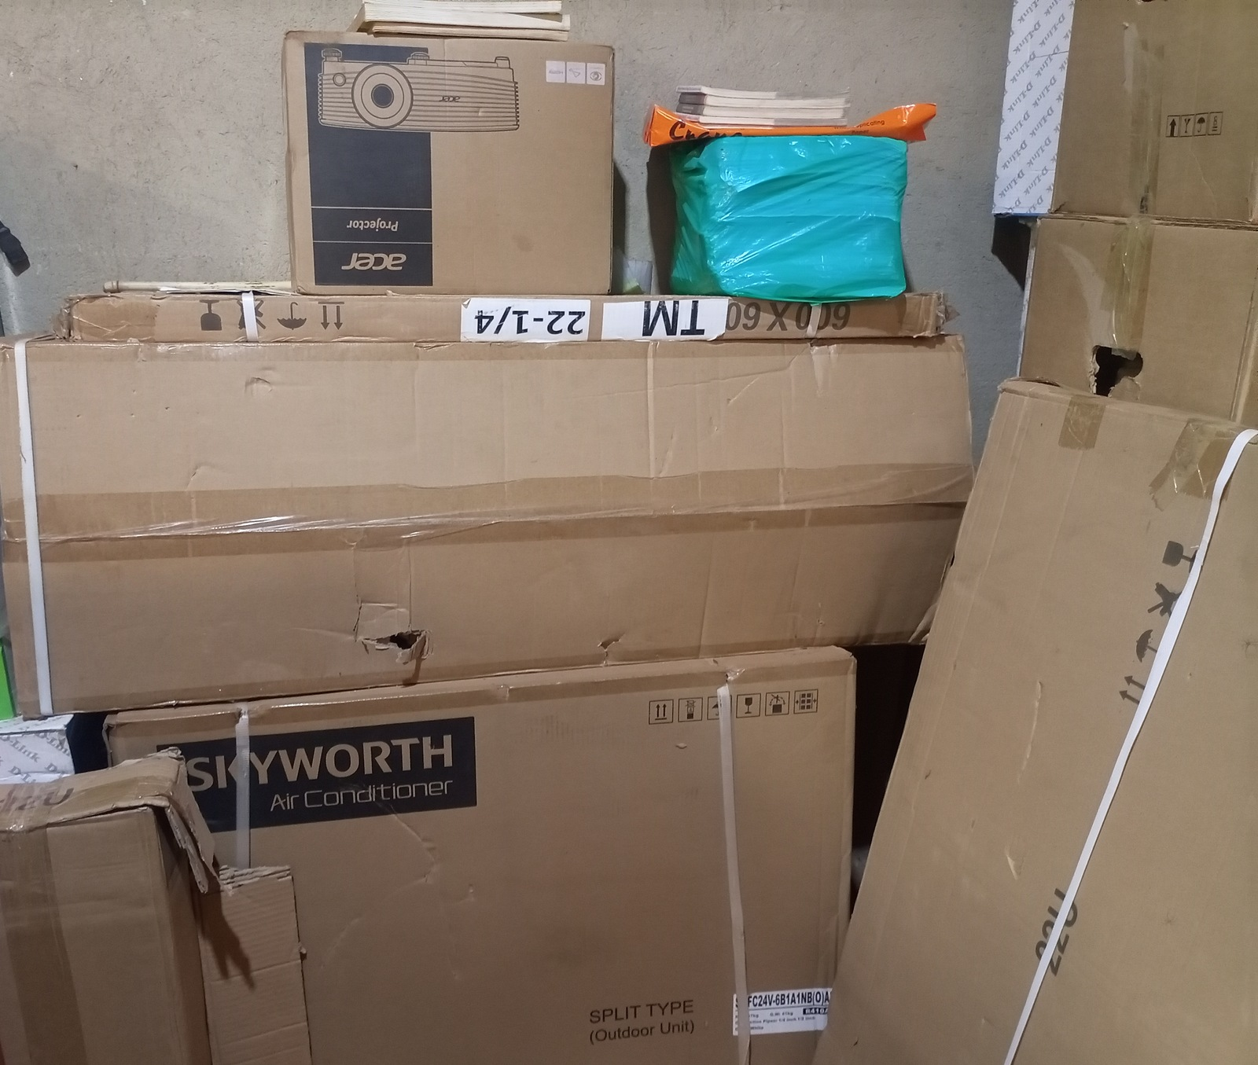 | 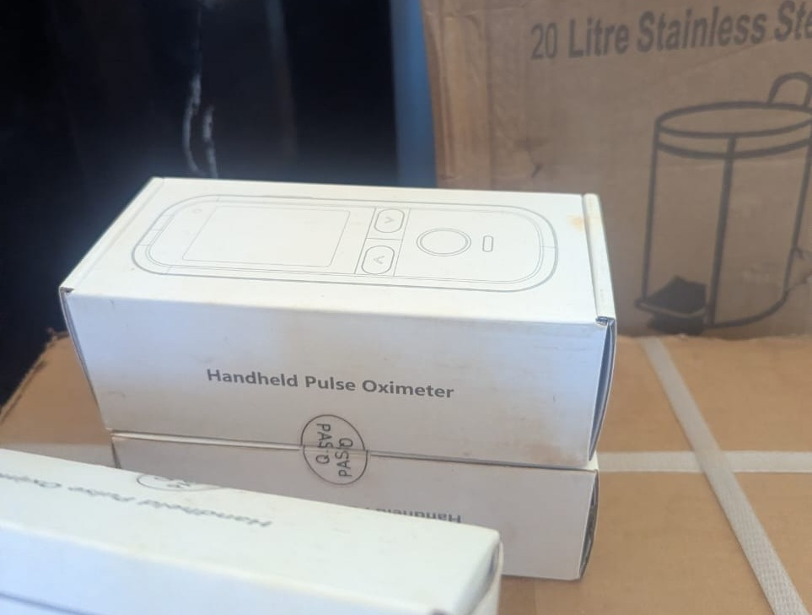
Boxed projector, air conditioner and other equipment in store at King Solomon Seed Secondary School in Kagadi District (Bunyoro), the school is still under construction | Boxed handheld pulse oximeters at Kibiri Health Centre III in Makindye-Ssabagabo Municipal Council (Buganda), where equipment was still being arranged after the facility opened on 31 August 2026

- Asset Marking and Identification
The verification revealed that only 49,457 (22.8%) of the movable assets were engraved and 167,279 (77.2%) were not engraved. Out of the engraved assets, 23,434 (10.8%) carried the UgIFT marking on them as a form of identification.

Identification and engraving varied at the different asset locations. The level of engravement stood at 31.5%, 25.3% and 15.2% for MDAs, Seed Secondary Schools and Health Centers respectively. Among the MDAs, the Ministry of Education and Sports accounts for most of the ministry assets that were not engraved, and these were mainly the TELA handsets and tablets. The details of asset identification are provided in figure 3.

Figure 3: Asset marking and Identification
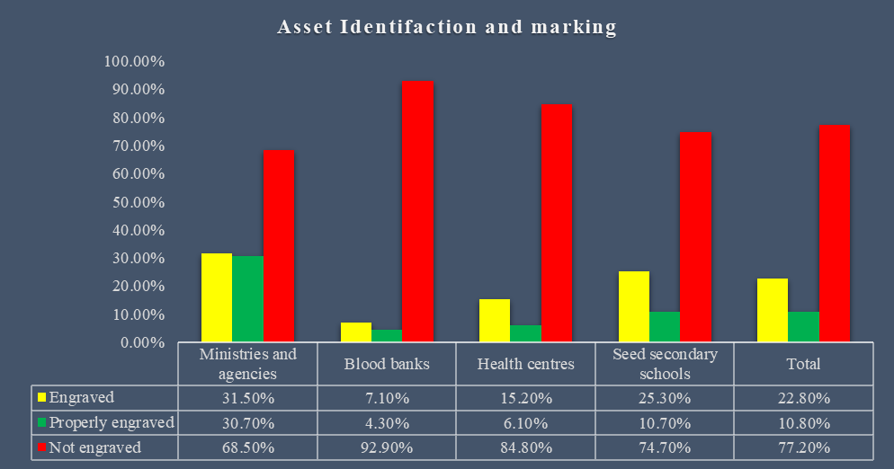

Below are some of the photos depicting the markings and identification engravements of assets across the institutions
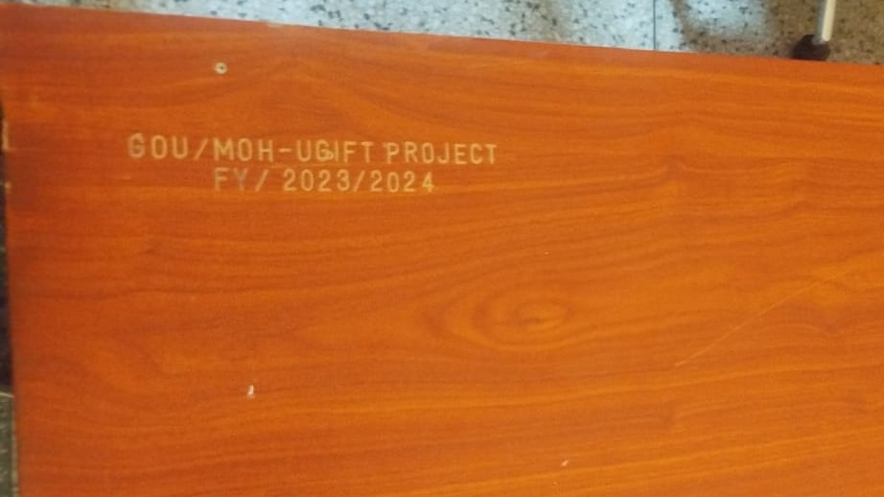 | 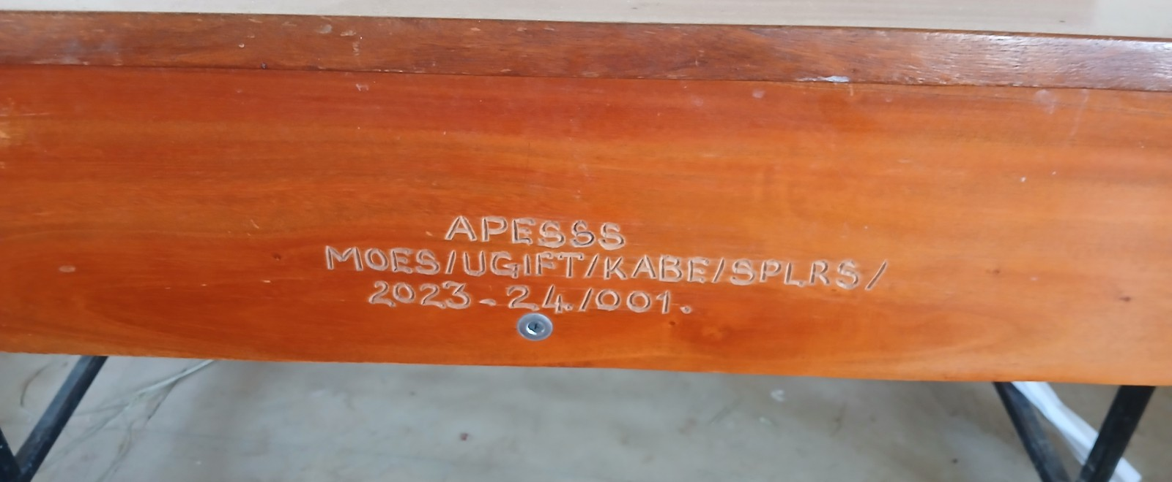
Engraving reading GOU/MOH-UGIFT PROJECT FY/2023/2024 on a desk at Namwaya Health Centre III in Tororo District | Engraving reading APESSS MOES/UGIFT/KABE/SPLRS/2023-24/001 on a desk at Aperikira Seed Secondary School in Kaberamaido District
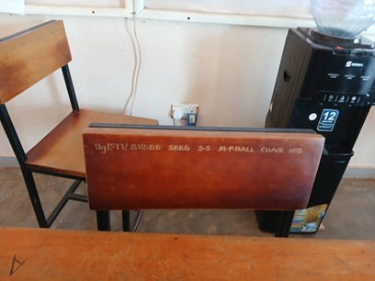 | 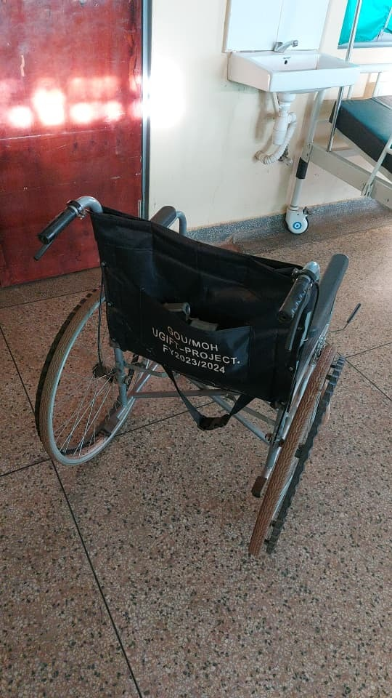
Chair engraved UgIFT/ BUDDE SEED S.S M-PHALL CHAIR with a serial number at Budde Seed Secondary School in Butambala District | Wheelchair backrest marked GOU/MOH UGIFT-PROJECT. FY2023/2024 at Kalemungole Health Centre III in Moroto District
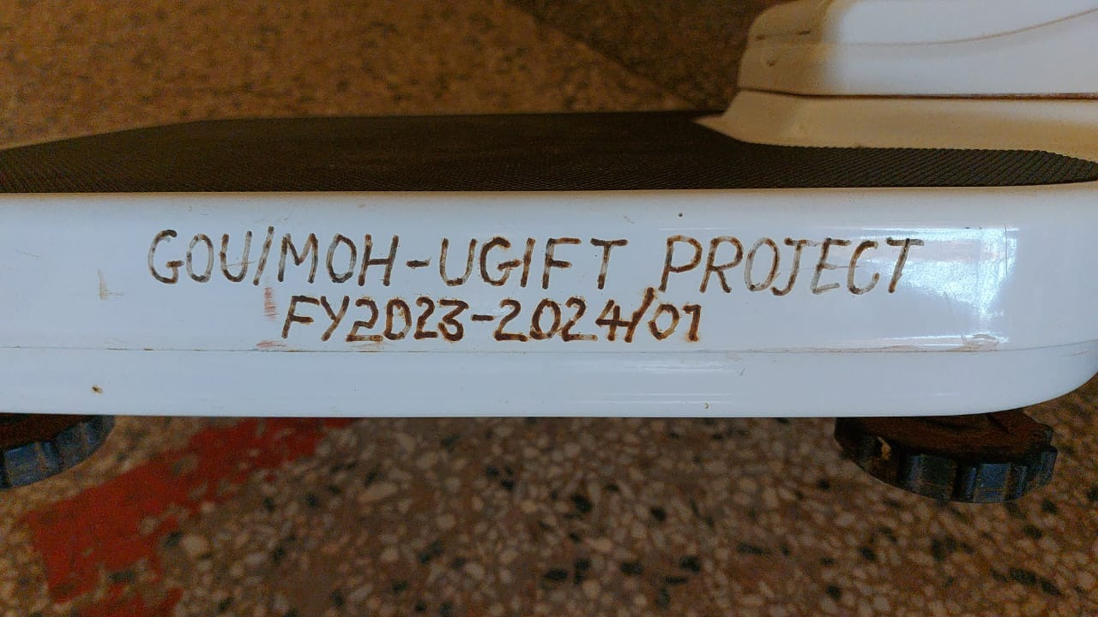 | 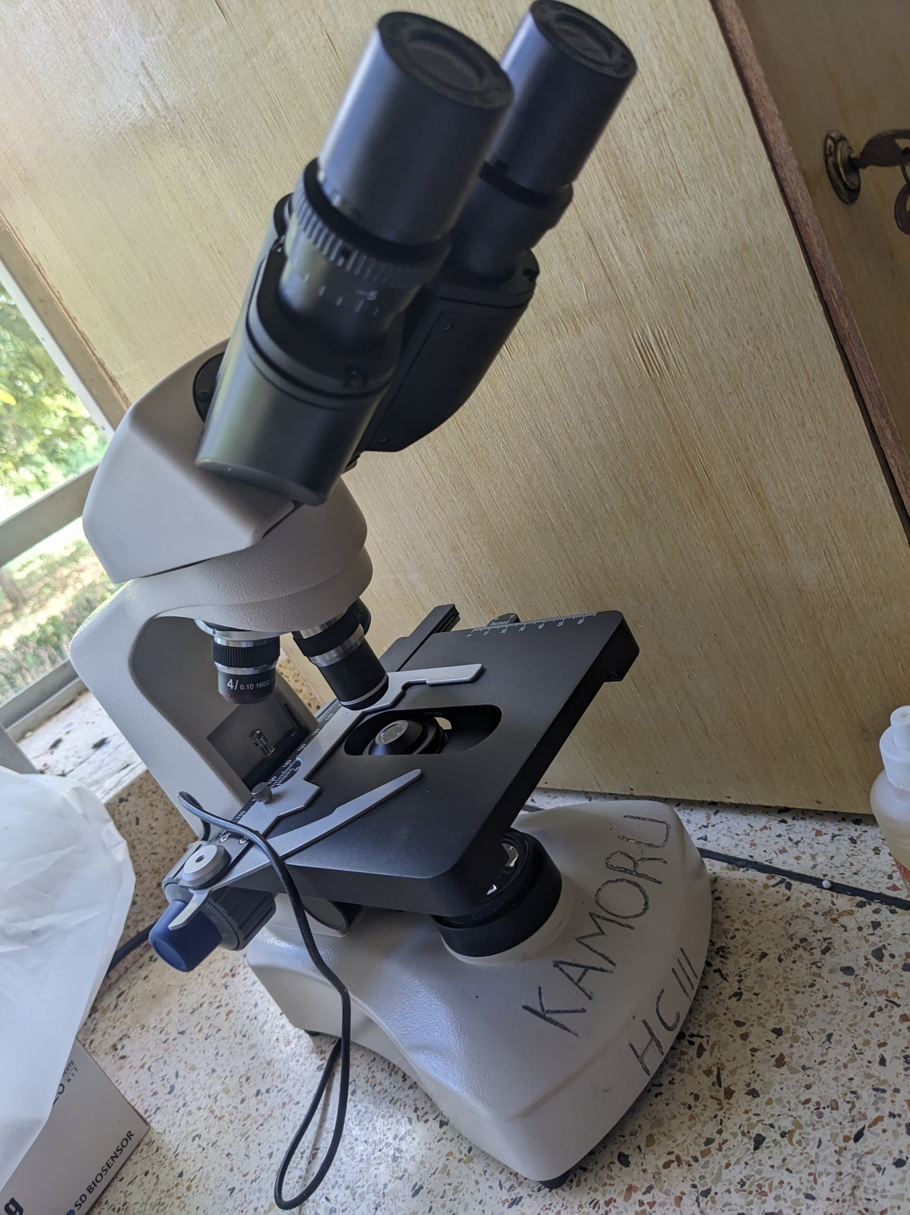
Engraving reading GOU/MOH-UGIFT PROJECT FY2023-2024/01 on a weighing scale at Kalemungole Health Centre III in Moroto District | Microscope marked KAMORU HC III by hand at Kamoru Health Centre III in Kotido District
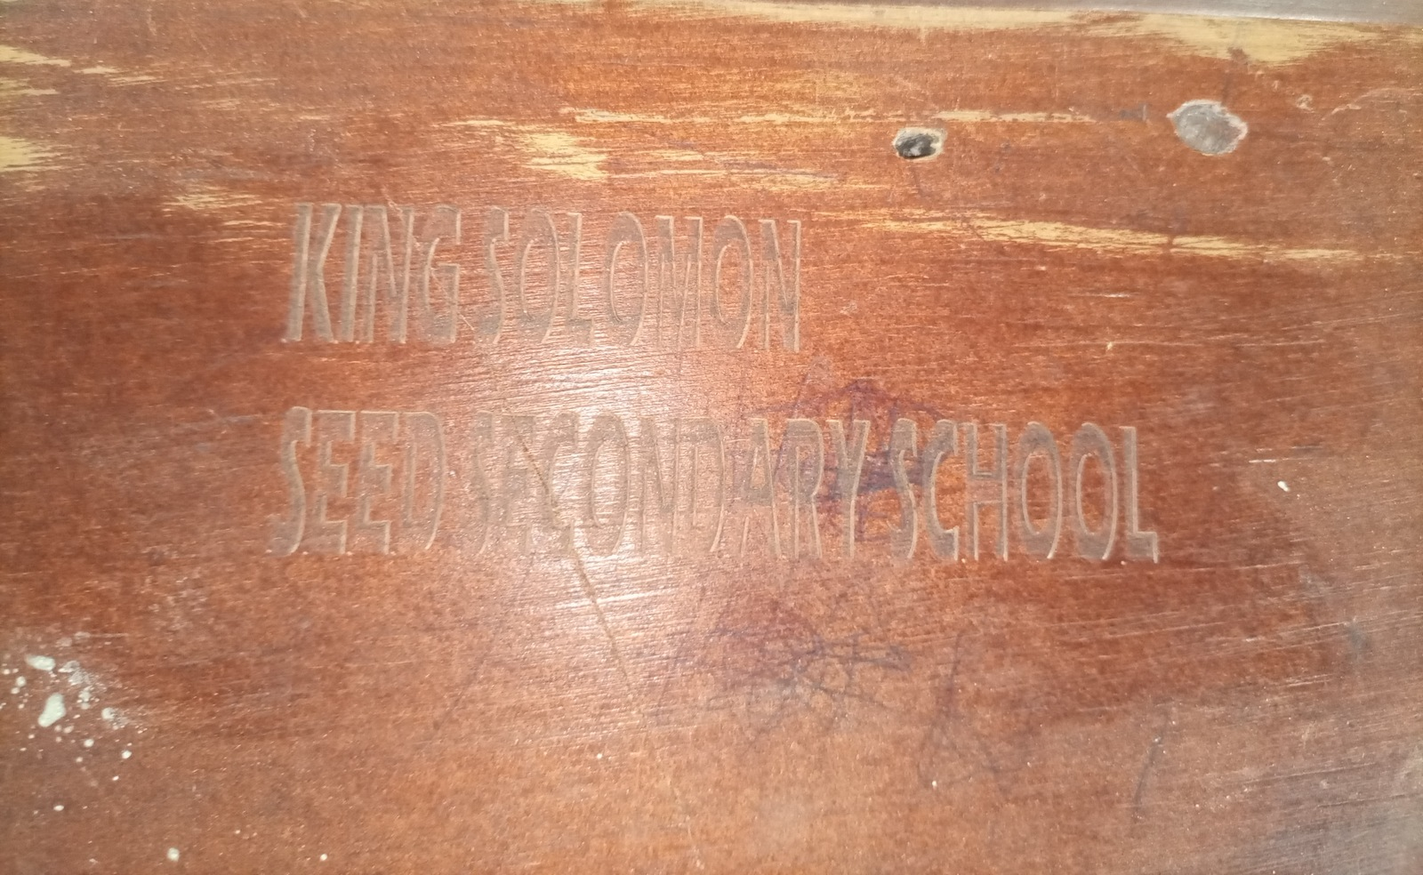 | 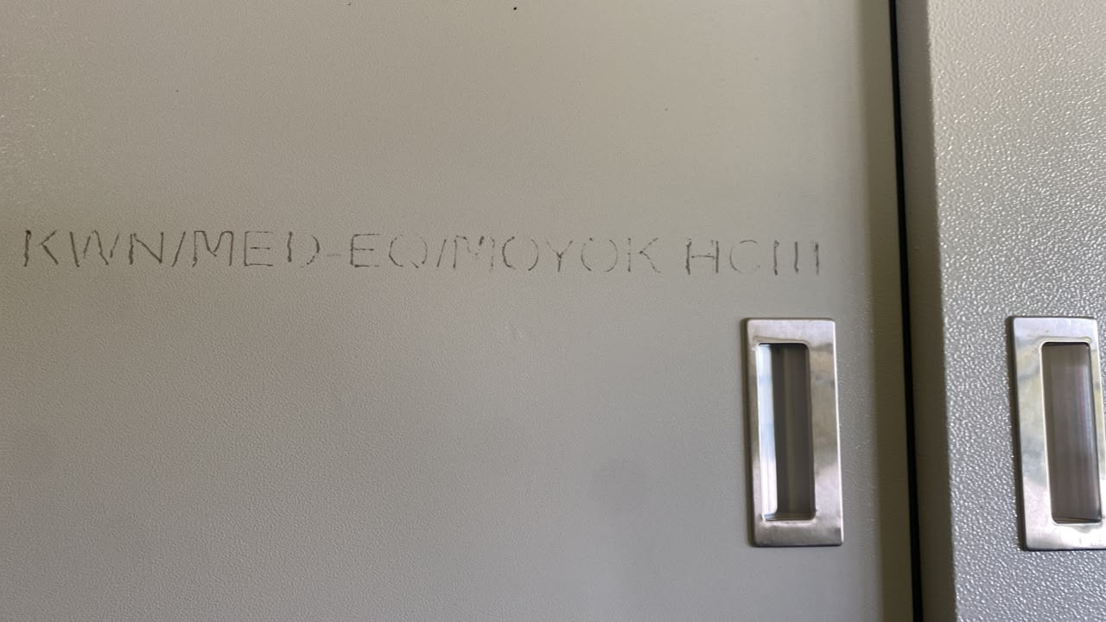
Engraving reading KING SOLOMON SEED SECONDARY SCHOOL, without a UgIFT marking, on furniture at King Solomon Seed Secondary School in Kagadi District | Engraving reading KWN/MED-EQ/MOYOK HCIII on a steel cupboard at Moyok Health Centre III in Kween District

- Financial analysis/ valuation

Overall, the 226,280 assets verified across the different institutions had a recorded value of UGX 971,615,425,138. Basing on the straight-line depreciation policy and the dates of deployment for the different assets, the computed net book value was UGX 808,621,845,836 as at 30 September 2026. The recorded values vary by classification with MDAs at UGX 31,822,306,095, Blood Banks UGX 1,451,584,715, Seed Secondary Schools UGX 678,247,549,426 and Health Centers UGX 259,662,849,164 as captured in the table 2.

Table 2: Overall Recorded Asset Value and Net Book Value
Institution | Assets | Recorded value UGX | Depreciation UGX | Net book value UGX
Ministries and agencies | 16,668 | 31,822,306,095 | 19,372,809,078 | 12,449,497,017
Blood banks | 626 | 1,451,584,715 | 514,105,544 | 937,479,171
Health centres | 63,606 | 259,662,849,164 | 41,291,859,808 | 218,378,252,366
Seed secondary schools | 145,376 | 678,247,549,426 | 101,549,907,057 | 576,704,905,370
Total | 226,276 | 971,184,289,400 | 162,728,681,487 | 808,470,133,924

National level Ministries and Agencies results

- Overall Asset availability at Ministries and Agencies
The exercise verified 16,668 assets of the different categories across all the thirteen Ministries and Agencies. In terms of categorization, the exercise verified 15,136 ICT equipment including desktop computers, laptops, tablets, Uninterruptible Power Supply (UPS), 76 Vehicles and motorcycles, 99 Furniture and fittings and 1,357 small equipment including shredders, binders, projectors among others.

By location, most assets (64.7%) were at MoES, MoWE and MAAIF while PPDA was found with only five assets including three Lenovo think pad Laptops, one HP Laser Jet Color Printer and one Samsung Galaxy tablet as indicated in figure 4 below.

Figure 4: UgIFT Assets available at each of the verified MDAs
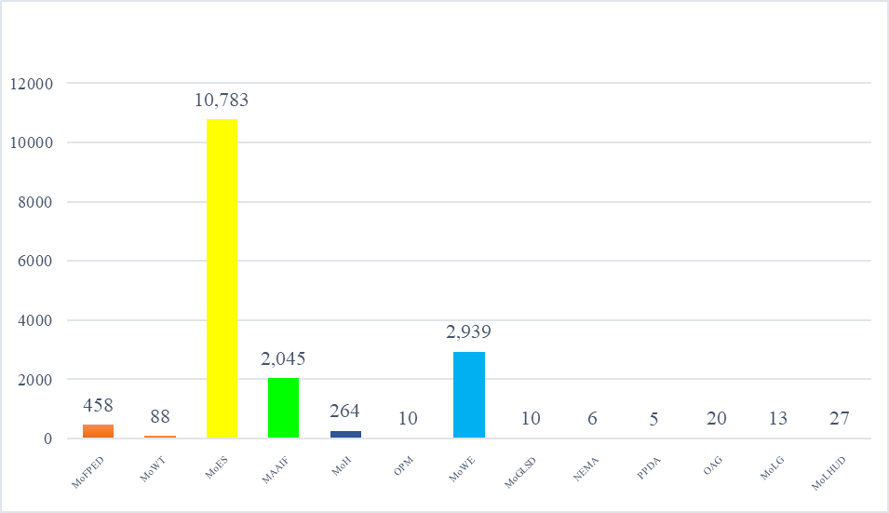

- MDA Asset Condition and functionality

At MDA level, apart from Ministry of Health that had one double cabin boarded off and three broken laptops at the Office of the Prime minister, the rest of the assets 16,664 (99.9%) were in good condition and were in use. The Ministry of Education and Sports holds 10,783 of these assets, mainly TELA handsets and tablets that were all in use in the various seed secondary schools across the country. LGFC and MoPS indicated that they never received UgIFT assets.

- Asset marking and Identification
At MDA level, there were 15,401 movable assets, of which 4,843 (31.4%) were engraved with 4,730 assets (30.7%) bearing the UgIFT marking. Majority of assets 10,558 (68.6%) were not engraved. Figure 5 below shows the identification status of the assets in the UgIFT implementing MDAs.

Figure 5: Asset marking and Identification at MDAs
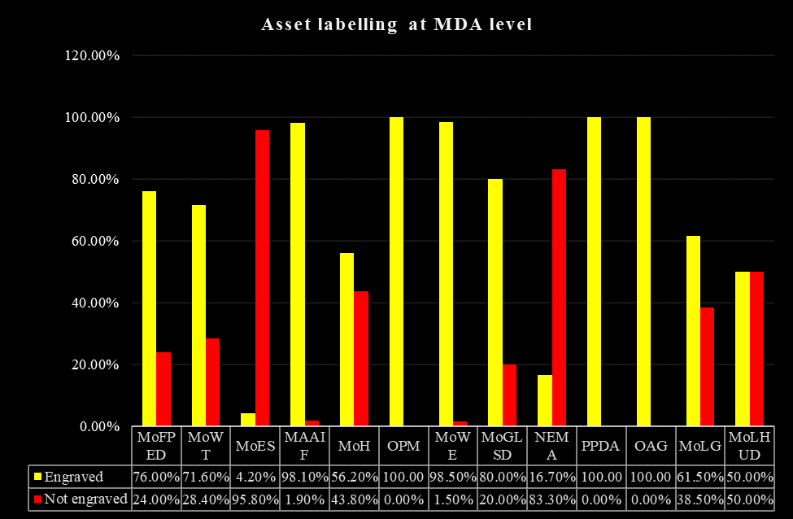

- Financial analysis/ valuation

MDA specific results

Ministry of Finance, Planning and Economic Development
Asset availability: The Ministry keeps a UgIFT asset register and the consolidated register for all MDAs that received UgIFT assets. A total of 458 assets were verified at the Ministry including 217 ICT items, 122 other assets, 99 furniture and fittings and 20 transport assets. The main items were office chairs and desks, desktop computers, tablets and 20 Toyota Hilux double cabin pickups.
Condition and functionality: All 458 assets (100.0%) were working and in use, and none was broken down.
Marking and identification: A total of 272 assets (76.0%) were engraved and 86 (24.0%) were not engraved. 252 assets were found to have the UgIFT marking. It was noted that the 20 double cabin pickups, did not have the UgFT labelling but were identified by their registration numbers only.

Financial Value of assets: The recorded value of the ministry's UgIFT assets is UGX 5,615,661,760.

Ministry of Works and Transport

Asset availability: The Ministry did not provide a UgIFT Asset Register. Physical verification at MoWT identified 88 assets of which 63 ICT items were mainly Lenovo desktop computers, monitors, uninterruptible power supply (UPS) units, video-conferencing equipment and HP Color LaserJet printers; one Toyota Hilux pickup; and 24 other assets. The 24 records grouped under other assets comprised 16 keyboards, four Dell OptiPlex 7090 desktop system units, two Lenovo Think Book notebooks, and two records without usable asset descriptions (entered as 'Ministry of Local Government' and 'PPDA'), as presented in Figure 6.

Figure 6: Assets verified at MoWT
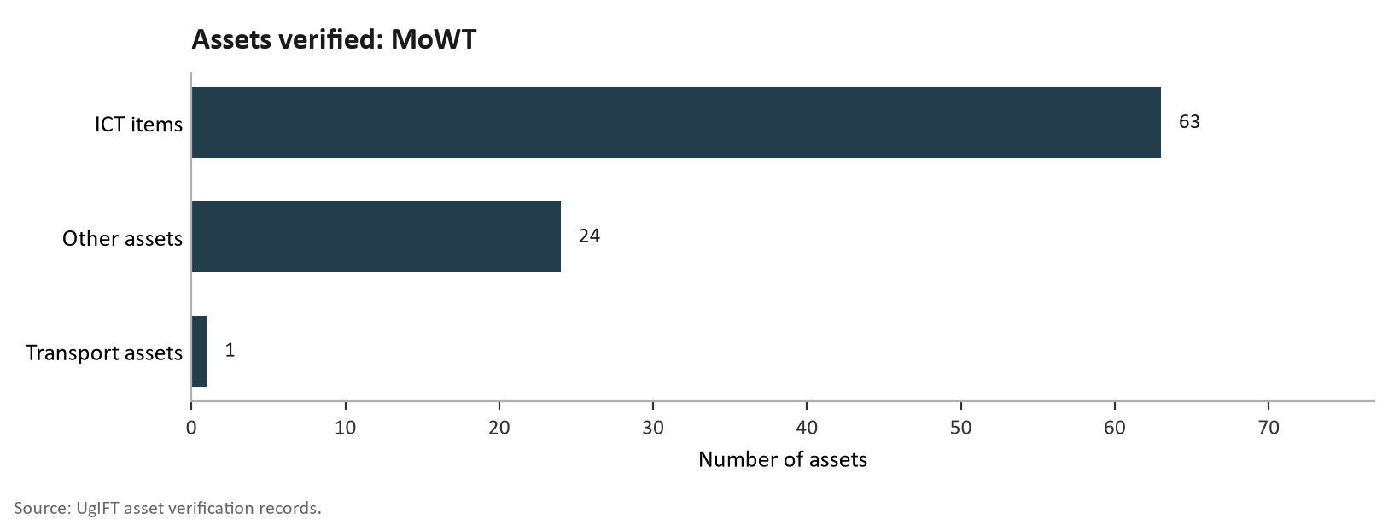

Condition and functionality: All the 88 assets that were verified were working and in use; none was broken down.
Marking and Identification: Of the 88 verified assets, 63 (71.6%) were engraved with 62 having the UgIFT marking while; 25 (28.4%) were not engraved.
Financial Value of assets: The recorded value was established as UGX 340,968,220 as presented in Table 3.
Table 3: MoWT asset values by category
Asset category | Assets | Recorded cost UGX
ICT equipment | 63 | 126,534,110
Vehicle | 1 | 196,018,110
Other assets | 24 | 18,416,000
Total | 88 | 340,968,220

Ministry of Education and Sports
Asset availability: The verification at the Ministry of Education and Sports (MoES) established that the Ministry had 10,783 assets. All the assets are ICT equipment and these include 9,324 TELA handsets, 1,001 tablets (976 of them, inspection tablets), 456 laptops, a photocopier and a printer. The breakdown of these assets is captured in figure 46c. Teacher, Effectiveness and Learner Achievement (TELA) is the system, financed by UgIFT, that the Ministry uses to monitor attendance and performance in schools; the handsets and inspection tablets are deployed in local governments but remain MoES assets.
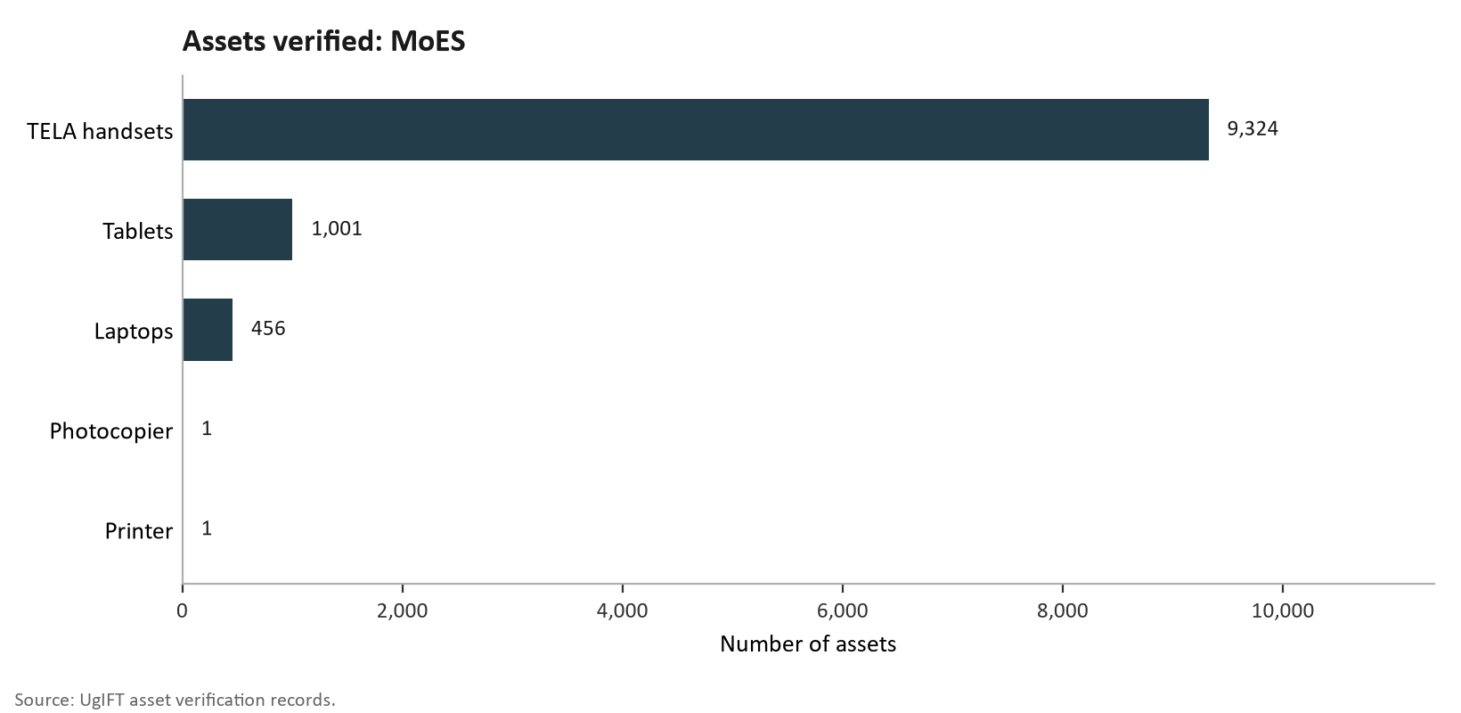
Figure 46c: Assets verified at MoES

Condition and functionality: All the 10,783 assets (100.0%) are in good working condition and in use. All the 456 laptops are in good condition, engraved with the UgIFT marking and in use.

Table 12b: Condition and use of assets at MoES
Status | Assets | Share
Good working condition and in use | 10,783 | 100.0%
Not working or not in use | 0 | 0.0%
Total | 10,783 | 100.0%

Marking and Identification: Of the verified assets, 458 (4.2%) were engraved, all with the UgIFT marking, while 10,325 (95.8%) were not engraved. None of the handsets or tablets were engraved..

Table 12c: Engravement status of assets at MoES
Engraving status | Assets | Share
Engraved with the UgIFT marking | 458 | 4.2%
Not engraved | 10,325 | 95.8%
Total | 10,783 | 100.0%

Financial Value of assets: The recorded value is UGX 14,760,581,751, the highest among the MDAs.

Ministry of Agriculture, Animal Industry and Fisheries
Asset availability: The team verified UgIFT assets at the Ministry of Agriculture, Animal Industry and Fisheries (MAAIF) and established that the Ministry had 2,045 assets. These included 1,206 ICT equipment, 2 vehicles and 837 others. The ICT items were mainly 819 tablets, 211 computers (162 desktops and 49 laptops), 149 monitors and 15 printers. The breakdown of the assets mentioned above is shown in figure 46d.
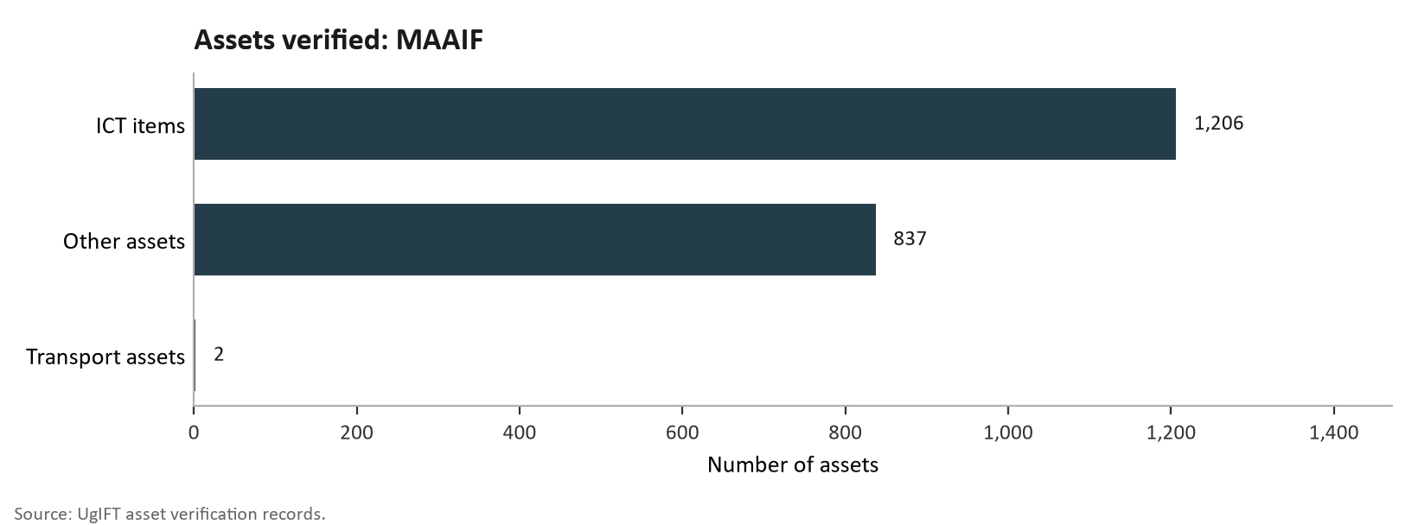
Figure 46d: Assets verified at MAAIF

Condition and functionality: All 2,045 assets (100.0%) are in good condition and in use. All 211 computers and 819 tablets are in good condition, engraved with a UgIFT marking and in use.

Table 12d: Condition and use of assets at MAAIF
Status | Assets | Share
Good working condition and in use | 2,045 | 100.0%
Not working or not in use | 0 | 0.0%
Total | 2,045 | 100.0%

Marking and Identification: Of the 1,227 verified assets, 1,204 (98.1%) are engraved, 1,200 (97.8%) with the UgIFT marking, and 23 (1.9%) were not engraved, among them two drones, a handheld global positioning system (GPS) unit and a projector. The laptops and printers were engraved with the the UgIFT marking.

Table 12e: Engravement status of verified assets at MAAIF
Engraving status | Assets | Share of verified assets
Engraved with the UgIFT marking | 1,200 | 97.8%
Other engraving | 4 | 0.3%
Not engraved | 23 | 1.9%
Total | 1,227 | 100.0%

Financial Value of assets: The recorded value was UGX 1,844,366,458.

Ministry of Health
The verification at the MoH established that the Ministry did not have a UgIFT Asset Register but relied on the listing provided by the Ministry of Finance, Planning and Economic Development.
Asset availability: A total of 264 assets were verified. Of the 264 assets, 39 were ICT equipment (laptops and photocopiers), 25 assets were transport assets (motor vehicles and motor cycles) and 200(Electronic shredders and Heavy Duty Binders) were other assets as indicated in Figure 46e.
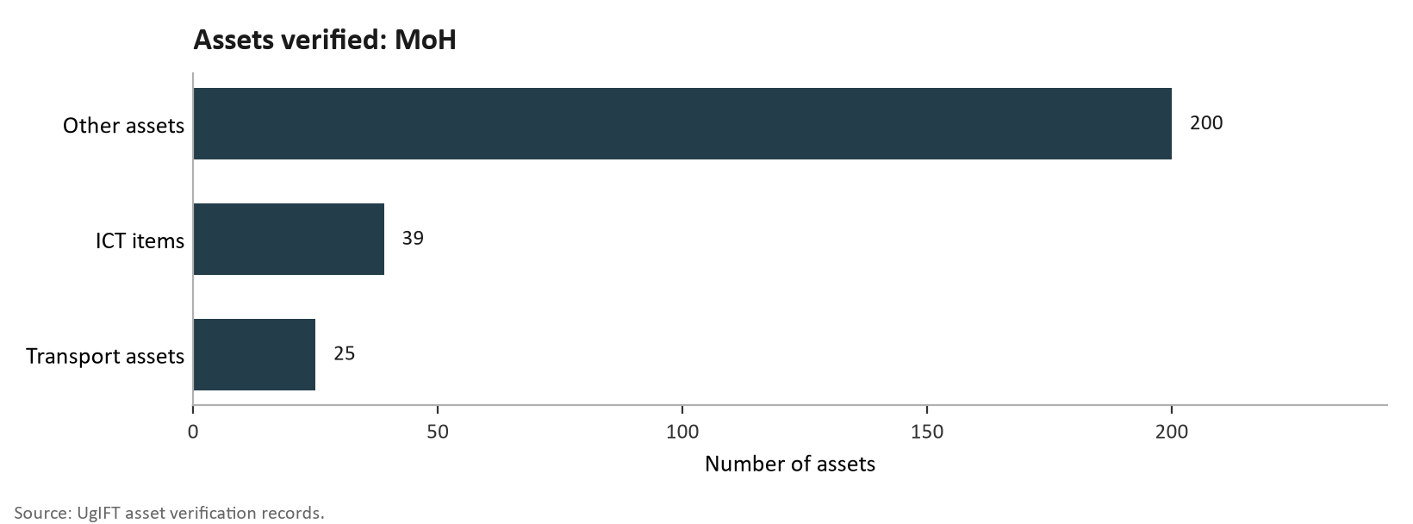
Figure 46e: Assets verified at MoH

Condition and functionality: The assets in good working condition were 263 (99.6%). Among those in good condition and in use were 26 computers (2 desktops and 24 laptops), Shredders and heavy duty binders. Only one asset i.e. a pick-up double cabin was not in good working condition and had been boarded off.

Marking and Identification: Out of the 73 movable assets, 41(56%) were engraved while 32 (44%) were not engraved. There were 14 (19%) assets that were engraved with UgIFT markings and serial numbers.

Financial Value of assets: The MoH assets had a recorded value of UGX 953,859,009.

Office of the Prime Minister
The UgIFT Assets Register in the Office of the Prime Minister was not in place at the time of verification and no list of assets was provided. The verification relied on the listing obtained from the Ministry of Finance, Planning and Economic Development.

Asset availability: Office of the Prime Minister received 10 assets which were all HP laptop computers as captured in Figure 46f.

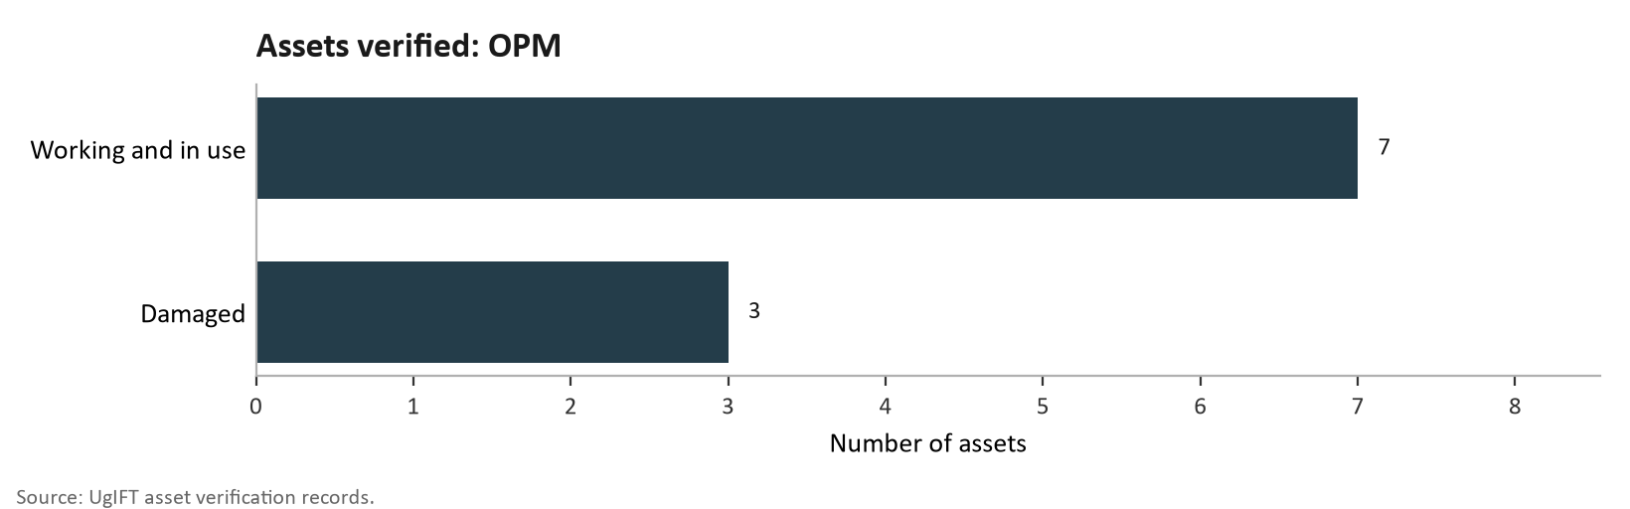
Figure 46f: Assets verified at OPM

Condition and functionality: Seven assets (70.0%) were in good working condition and in use. Three (30.0%) were damaged, and out of use. Which were the three that were damaged?

Marking and identification: All the 10 laptops were engraved with the UgIFT markings.

Financial Value of assets: The recorded value of the assets in OPM was UGX 53,535,300.

Office of the Prime Minister
Asset availability: The Assets Register for the Office of the Prime Minister was not obtained and no list of assets was provided. The verification relied on the listing obtained from the Ministry of Finance, Planning and Economic Development. Office of the Prime Minister received 10 assets which were all HP laptop computers as shown in Figure 46f.
Figure 46f: Assets verifiedat OPM

Asset condition and functionality: Seven assets (70.0%) were in good working condition and in use. Three (30.0%) were damaged, and out of use.
Asset Marking and identification: All the 10 laptops were properly engraved with the UgIFT markings.
Financial value of assets: The recorded value of these computers was UGX 53,535,300.

1.1.1 Ministry of Water and Environment
Asset availability: The Asset Verification at the Ministry of Water and Environment established that the Ministry keeps a general register which does not conform to IFMIS Standards. The register recorded 2,939 assets, all classified as ICT equipment. The verified assets received by the Ministry were 2,368 tablets out of which 2,344 were of Euron type, 188 Computers with their keyboards and UPS units of which 31were laptops. The Ministry also received 16 real time kinematic GPS machines.

However, other assets were identified which included157 keyboards recorded with Dell OptiPlex computers, 7 airborne ground-penetrating radar units, 3 Samsung Galaxy Tab S9 tablets, 2 Lenovo Think Book notebooks, 1 Kyocera heavy-duty copier, 1 Huawei 65-inch infrared screen and 1 UPS unit.

Asset condition and functionality: The findings further indicated that all 2,939 assets (100.0%) were in good working condition..
Marking and Identification: The Ministry received a total of 2939 assets. Of the2,782 verified assets2,740 (98.5%) were engraved, 2,707 (97.3%) with the UgIFT marking. Forty-two 42 (1.5%) were not engraved.
Financial Value of the assets: The recorded value was UGX 5,993,100,537.

Ministry of Gender, Labour and Social Development
Asset availability: The Asset Verification at the Ministry of Gender, Labour and Social Development established that the Ministry keeps a UgIFT asset register which had 10 UgIFT assets. These comprised of 8 Lenovo ThinkPad Laptops, and 2 Samsung Tablets. Figure 46h presents the UgIFT assets verified at MoGLSD.

Asset condition and functionality: The findings further indicate that all the verified UgIFT assets were in good working condition and in use.

Marking and Identification: A total of Eight Lenovo ThinkPad Laptops (80.0%) were properly engraved with the UgIFT markings and the Two Samsung Tablets (20.0%) were not engraved.

Financial Value of the assets: The recorded value of the assets was UGX 20,120,000.

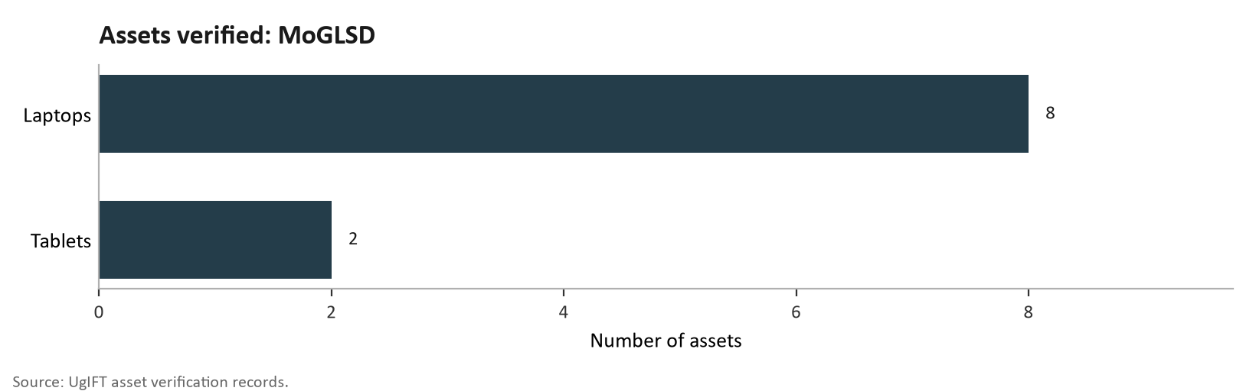
Figure 46h: Assets verified at MoGLSD

National Environment Management Authority
Asset availability:
National Environment Management Authority (NEMA) had 6 ICT items; 4 laptops, a printer and a heavy-duty photocopier.

Condition and functionality: All 6 (100.0%) were working and in use.
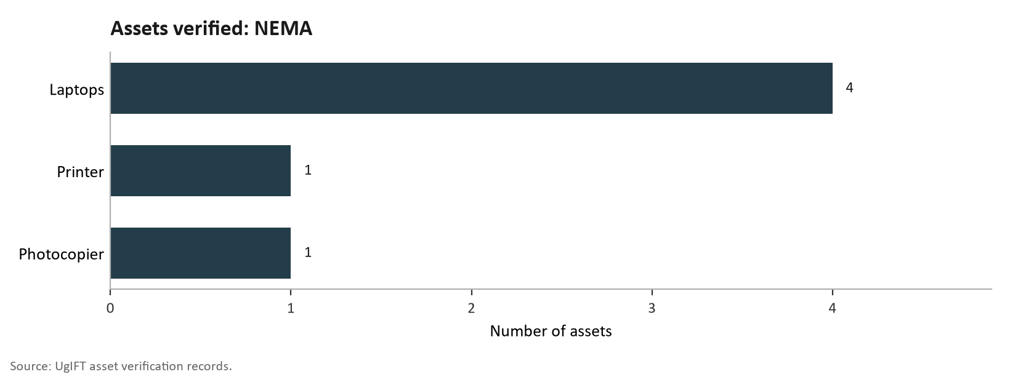
Figure 46i: Assets verified at NEMA

Asset marking and identification
One (16.7%) i.e. the heavy duty photocopier was engraved while the other 5 (83.3%) were not engraved.

Financial value of Assets: The recorded value is UGX 27,324,409.

Public Procurement and Disposal of Public Assets Authority
Public Procurement and Disposal of Public Assets Authority (PPDA) did not provide a UgIFTAsset Register. The verification relied on the information obtained from the Ministry of Finance, Planning and Economic Development.

Asset availability: A total of 5 assets were verified in PPDA; these were 3 Lenovo ThinkPad laptops, a Samsung Galaxy tablet and an HP printer as indicated in Figure 46j.
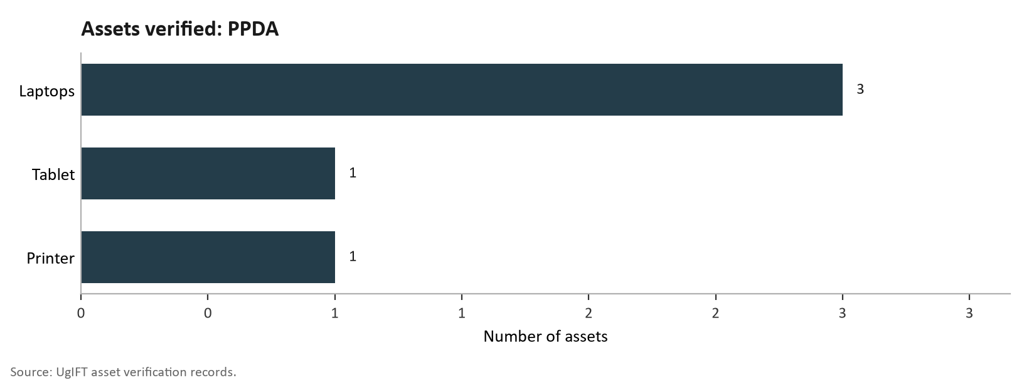
Figure 46j: Assets verified at PPDA

Asset condition and functionality: All the 5 assets were in good working condition and in use.
Asset marking and identification: All the laptops, tablets and printer were engraved with the UgIFT marking.
Financial Value of assets: The MF register does not state a recorded cost or net book value for these assets.

Office of the Auditor General (OAG)

Asset availability: Evidence gathered during the verification confirmed that OAG had no UgIFT asset register but presented a list which indicated that the institution had 20 assets; 18 of which were ICT items (16 laptops and 2 printers) and 2 pickup vehicles. The above information is depicted in figure 46k.

Asset condition and functionality: All 20 (100.0%) assets were in good condition and in use.

Asset marking and Identification: Six (30.0%) were engraved with UgIFT markings and 14 (70.0%) did not have with UgIFT markings. The engravement was carrying the office's own asset code or vehicle registration number for the two pickups.

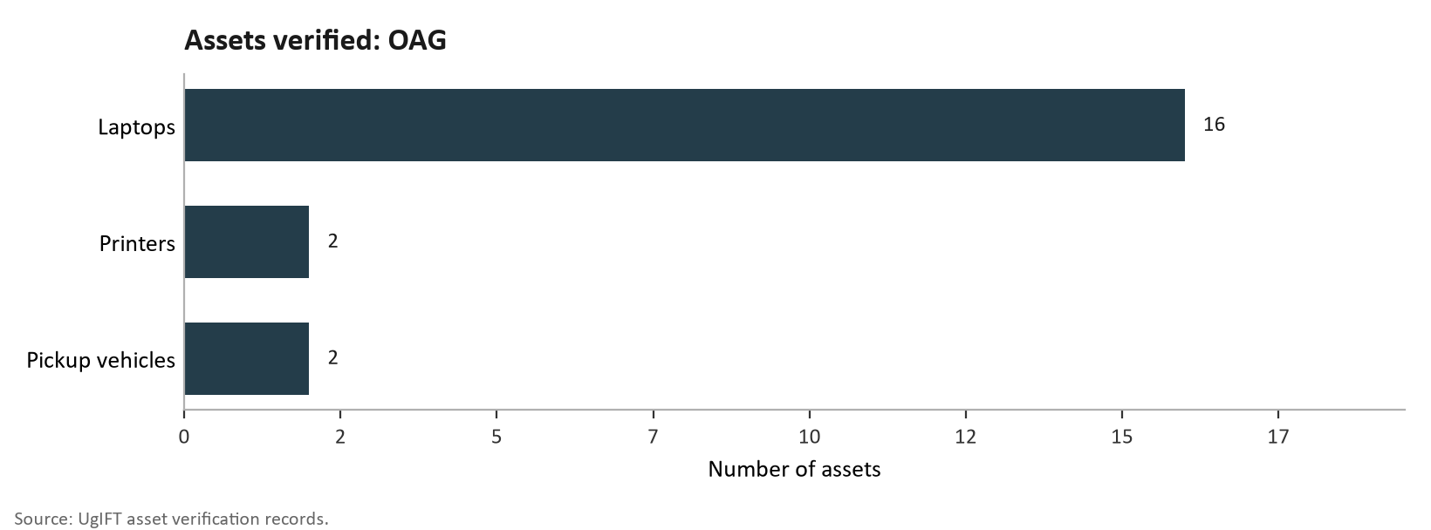
Figure 46k: Assets verified at OAG

Financial value of Assets: The assets were worth UGX 228,773,680.

Ministry of Local Government
Asset availability: The asset verification at the Ministry of Local Government (MoLG) established that the Ministry kept a UgIFT asset register and had 13 UgIFT assets; one double-cabin pickup and 12 ICT items. The ICT assets comprised of 6 computers, 4 computer peripherals and 2 heavy duty photocopiers. Figure 46l presents the UgIFT assets verified for MoLG.
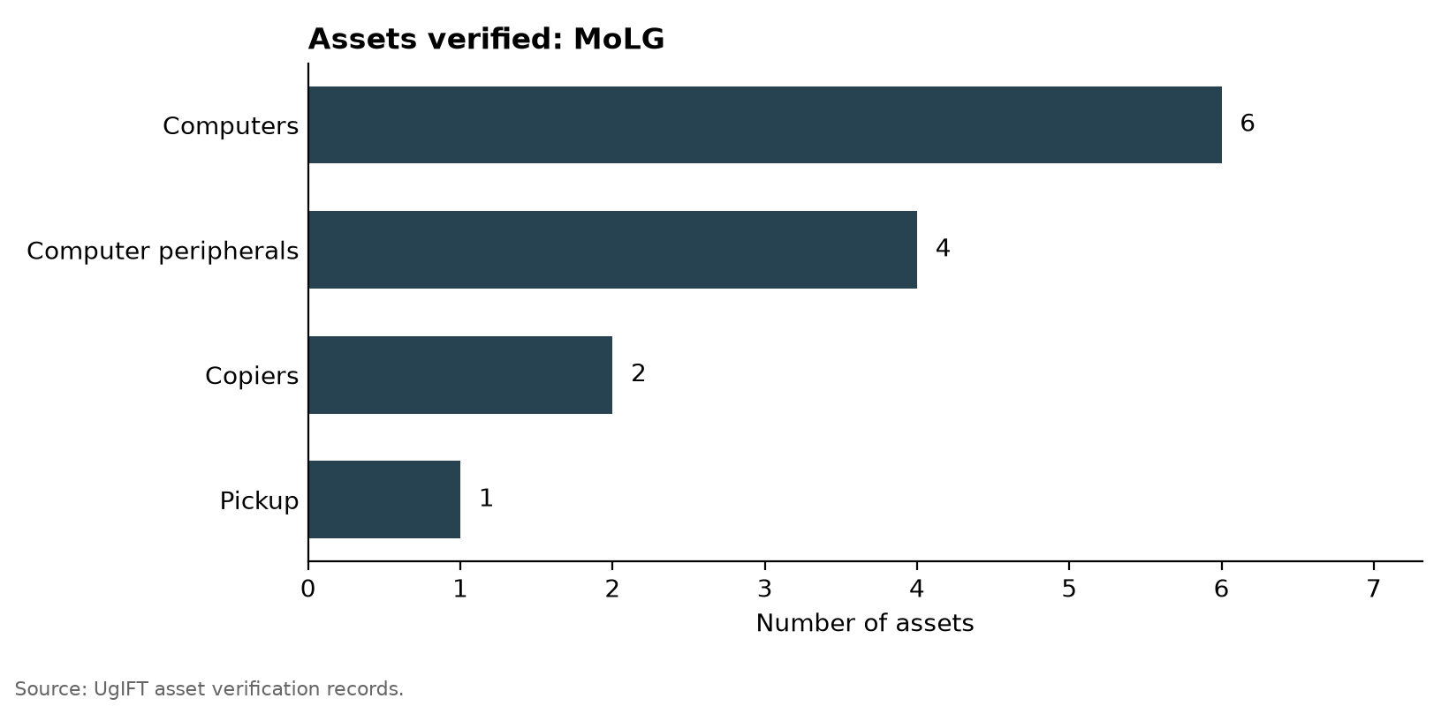
Figure 46l: Assets verified at MoLG

Asset condition and functionality: The findings further indicate that all 13 (100.0%) verified UgIFT assets were in good condition and in use.

Asset marking and identification: Out of the 13 assets, eight (61.5%) were engraved while five (38.5%) were not. Of the eight assets that were engraved, 7 (53.8%) were engraved with UgIFT markings while one was not. In terms of ICT equipment which formed the bulk of assets, 3 (50.0%) were engraved and 3 (50.0%) were not.

Financial Value of assets: The recorded value of the assets is UGX 31,114,879.

Ministry of Lands, Housing and Urban Development
Asset availability: The findings from the verification exercise indicated that MoLHUD had 27 UgIFT assets. These included 25 Honda motorcycles and 2 other assets (Helmets).
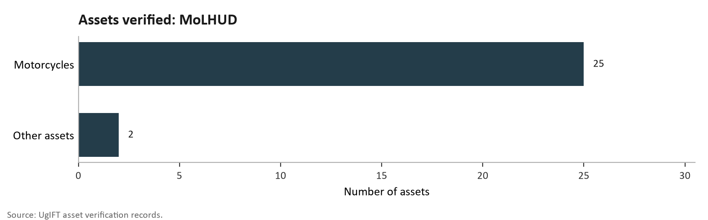

Figure 46m: Assets verified at MoLHUD

Additionally, the Ministry received survey equipment and other motorcycles that it gave out to local governments.

Asset condition and functionality: All the 27 (100.0%) were in good condition and in use.

Asset marking and Identification: All the 27 (100.0%) were not engraved with UgIFT markings. It was also noted that the motorcycles did not have the UgFT labelling but were identified by their registration numbers only.

Financial Value of assets: The recorded value of the assets is UGX 597,549,997.

Results from blood banks
UgIFT financed the construction of the Arua and Hoima regional blood banks and the rehabilitation of Soroti Regional Blood Bank. The Arua and Hoima blood banks were completed and commissioned. The three Blood Banks operate under Uganda Blood Transfusion Services (UBTS) and were verified.

Asset availability: The blood banks had a total of UgIFT asset base of 626 fixed assets inclusive of the Assets at the Uganda Blood transfusion services. The exercise verified all assets at the three regional blood banks as follows. Arua Regional Blood Bank had 277 assets, Hoima Regional Blood Bank had 119 and Soroti Regional Blood Bank had 115 assets.

Asset Condition and functionality
Assets at the regional blood banks were generally in good working condition. Only Arua regional blood bank had six broken assets.

Marking and Identification
Of 605 movable assets, 43 (7.1%) were engraved and 562 (92.9%) were not engraved. Twenty-Six (4.3%) were engraved with the UgIFT marking and 17 (2.8%) carried another marking . Figure 59 shows the position. Table 25 sets out the counts.

Financial aspects
The recorded value was UGX 1,451,584,715 and net book value at 30 September 2026 was UGX 937,479,171. Accumulated depreciation was UGX 514,105,544.

Table 26: Recorded value and net book value: Blood banks

Institution | Assets | Recorded value UGX | Depreciation UGX | Net book value UGX
Arua Regional Blood Bank | 277 | 1,091,262,791 | 430,462,000 | 660,800,791
Hoima Regional Blood Bank | 119 | 278,006,206 | 21,690,290 | 256,315,916
Soroti Regional Blood Bank | 115 | 29,317,538 | 25,122,550 | 4,194,988

The photos below depict some of the assets of the blood banks

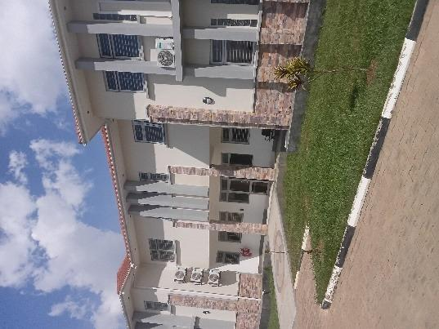 | 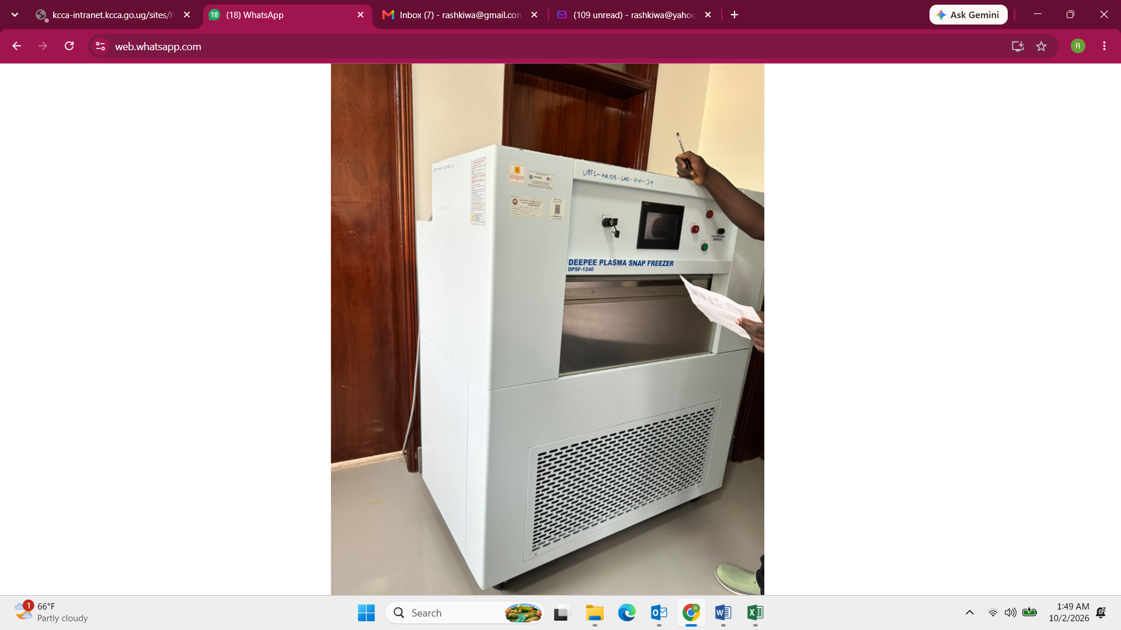
Completed blood bank building at Arua Regional Blood Bank, Arua City | Soroti Blood bank
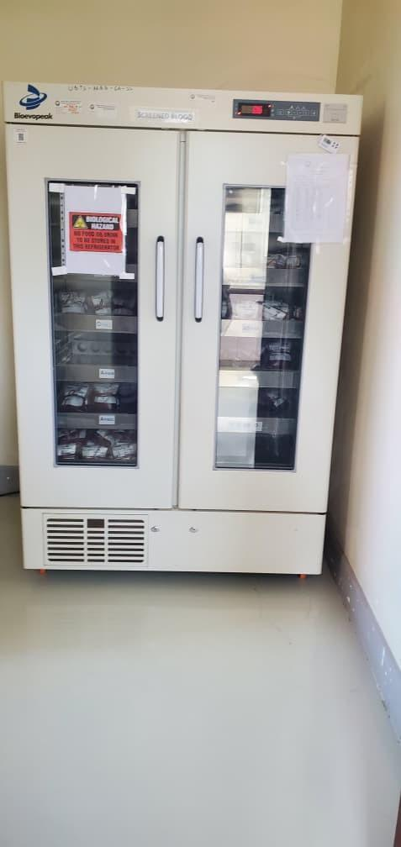 | 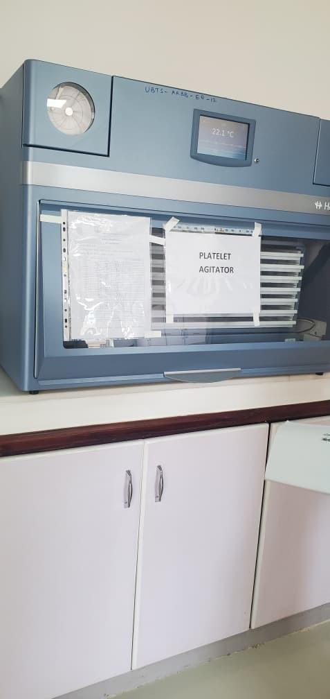
Blood bank refrigerator at Arua Regional Blood Bank, Arua City | Platelet agitator at Arua Regional Blood Bank, Arua City
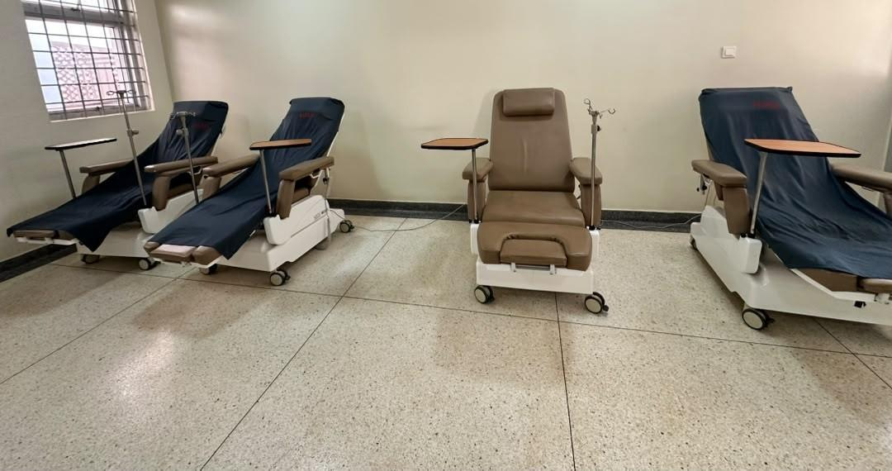 | 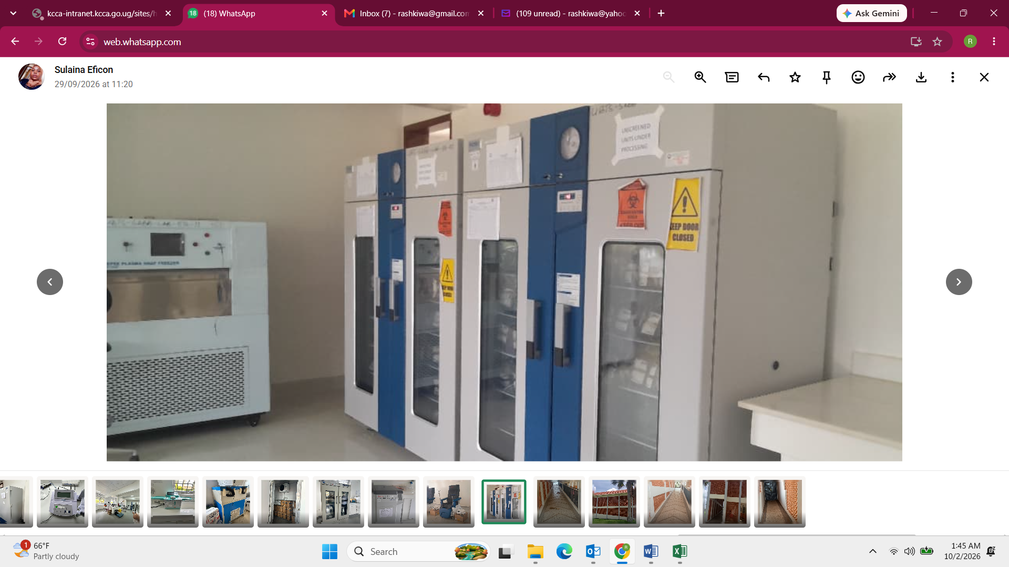
Couches in the donor room at Hoima Regional Blood Bank, Hoima City | Blood bank refrigerator Soroti Blood bank
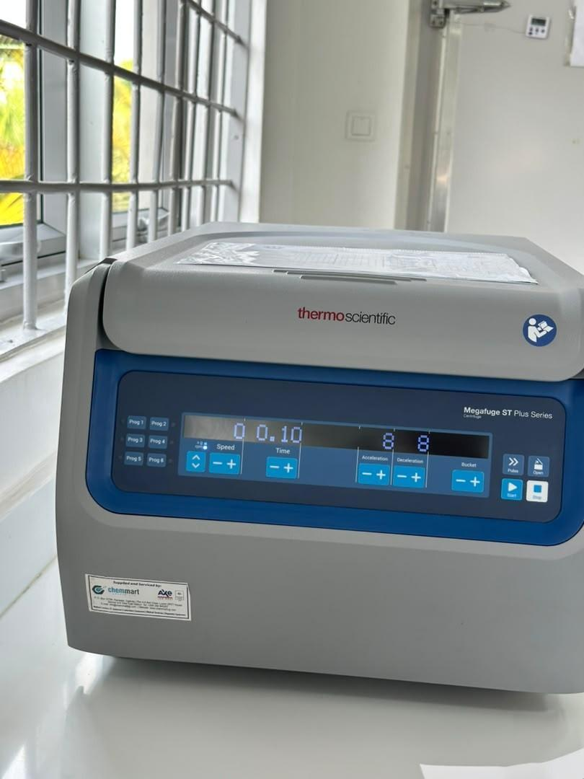 | 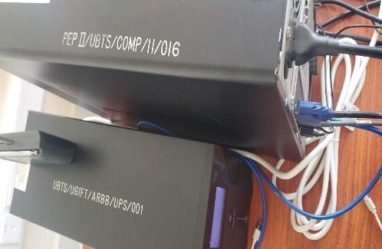
Benchtop centrifuge at Hoima Regional Blood Bank, Hoima City | Markings PEP II/UBTS/COMP/11/016 and UBTS/UGIFT/ARBB/UPS/001 on uninterruptible power supplies at Arua Regional Blood Bank, Arua City

Local Government Level Asset Verification results

The asset verification exercise at the LG level covered all the 176 LGs. It was established that 629 UgIFT facilities received support from the UgIFT Program of which 371 are Health Centres and 258 are Seed Secondary Schools. A total of 208,975 assets were verified, of which 63,599 were for Health Centres and 145,376 were for Seed Secondary Schools . Of the 208,975 assets, 195,503 (93.6%) were in good condition and in use while 3,119 (1.5%) were not in use. 3,382 were broken assets. The details are presented in sections 3.3 (Health Centres) and 3.4 (Seed Secondary Schools).

Health Centres

Availability of the assets
The verification findings indicated that health facilities received 63,599 assets across the different categories which include; clinical equipment, clinical furniture, maternity ward equipment, ICT equipment, buildings, land and other movable assets. Consumables are excluded. Table 13 and Figure 47 present the assets by category.

Table 13: Availability of assets in Health Centres
Asset category | Assets verified | Share
Clinical equipment | 25,960 | 40.8%
Clinical furniture | 20,139 | 31.7%
Maternity ward equipment | 7,438 | 11.7%
ICT equipment | 410 | 0.6%
Health centre buildings | 1,525 | 2.4%
Other health centre assets | 8,124 | 12.8%
Land | 3 | 0.0%
Total | 63,599 | 100.0%

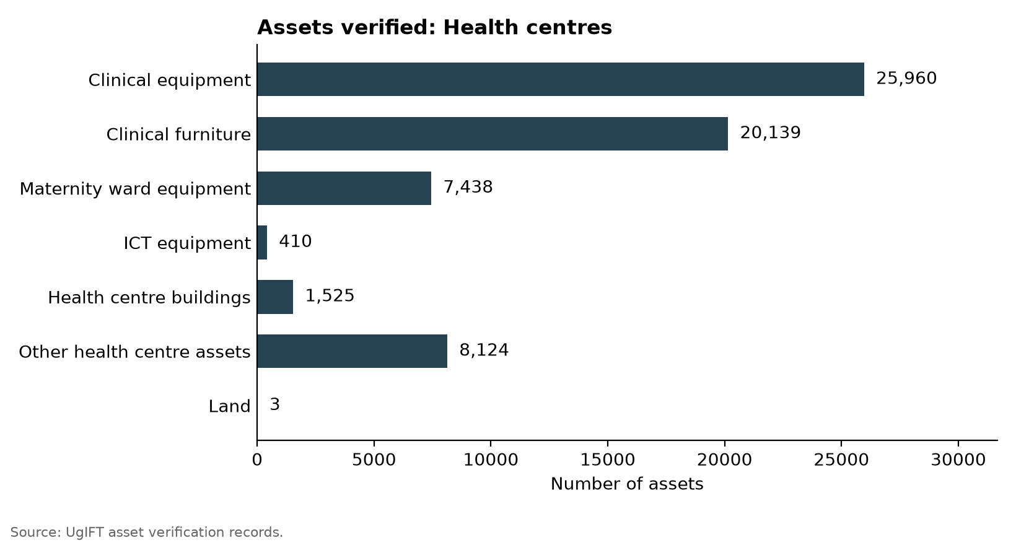
Figure 47: Assets verified: Health centres

Asset condition and functionality
The findings indicated that of the 63,599 health centre assets, 60,547 (95.2%) were in good condition, 57,918 (91.1%) were in use and 2,629 (4.1%) were in the store. A further 660 (1.0%) were broken down and 2,392 (3.8%) were not in use for other reasons. ICT equipment had the lowest share in good condition at 89.3%. Figure 48 and Table 14 present the condition of the assets.

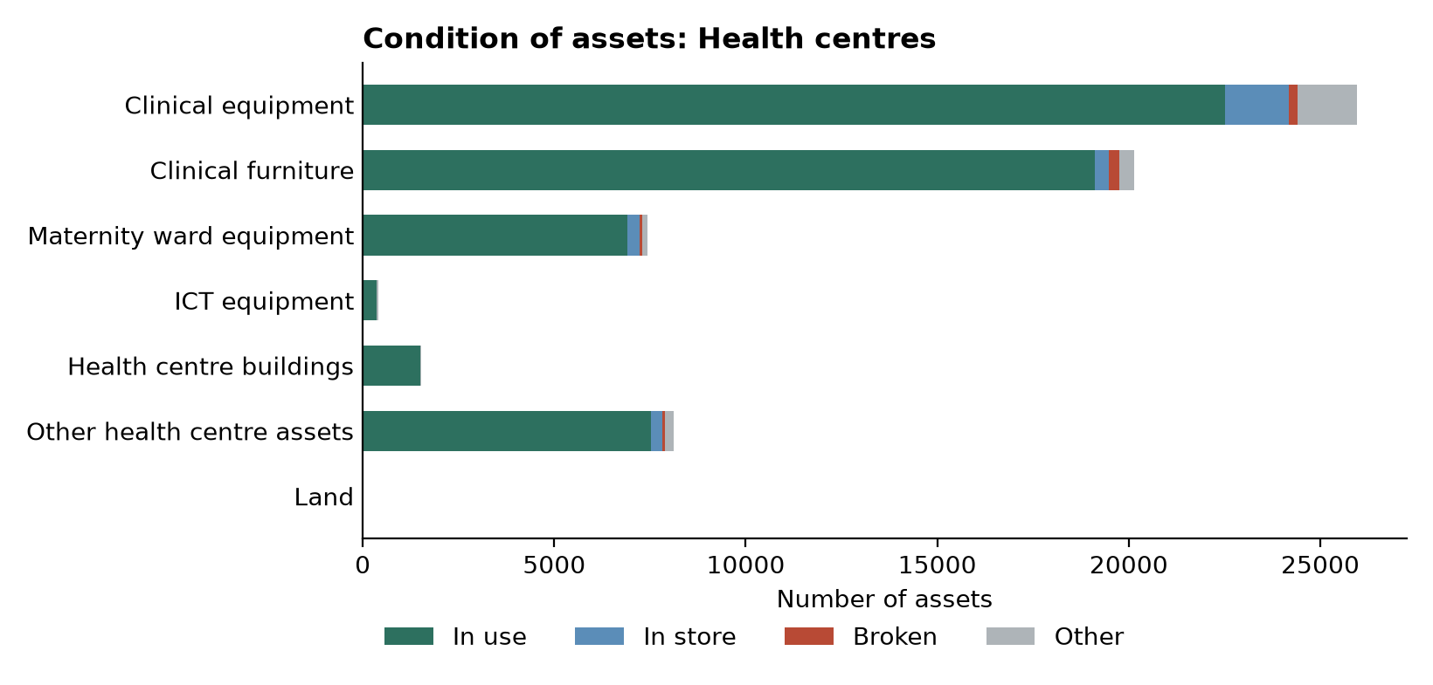
Figure 48: Condition of assets: Health centres

Table 14: Condition of assets: Health centres
Asset category | Assets verified | Good condition |  | Broken | Other
Asset category | Assets verified | In use | In store | Broken | Other
Clinical equipment | 25,960 | 22,507 | 1,677 | 220 | 1,556
Clinical furniture | 20,139 | 19,110 | 360 | 277 | 392
Maternity ward equipment | 7,438 | 6,918 | 303 | 69 | 148
ICT equipment | 410 | 361 | 5 | 5 | 39
Health centre buildings | 1,525 | 1,495 | 0 | 6 | 24
Other health centre assets | 8,124 | 7,527 | 284 | 83 | 230
Land | 3 | 3 | 0 | 0 | 0
Total | 63,599 | 57,918 | 2,629 | 660 | 2,392

Of the 2,392 (3.8%) health-centre assets not in use for other reasons, included those that were not delivered to the facility (still in stores at LGs), idle, had missing parts, lacked power, not required at the facility, rooms/ wards for installation of the equipment, held at another facility, awaiting installation, lost/missing and unused because staff were not trained or no specialist was available to operate the equipment. Examples include a wall-mounted blood pressure machine at Butawata Health Centre III (Mubende District) recorded as not functional; a wheelchair at Aarapoo Health Centre III (Serere District) that had not been delivered; a patient screen at Ayer Health Centre III (Kole District) that was on the delivery note but not seen; a pediatric bed at Okwerodot Health Centre III (Kole District) supplied without a mattress; and an autoclave machine at Anamwany Health Centre III (Amolatar District) left unused for lack of electricity.

In terms of buildings, they are categorised into two i.e. residential (482) and non-residential buildings (1,043). Residential buildings are staff houses and other buildings described as residential. Table 15 and Figure 49 depict the building categories.

Table 15: Health Centre Buildings
Building type | Assets verified | Share
Residential buildings | 482 | 31.6%
Non-residential buildings | 1,043 | 68.4%
Total | 1,525 | 100.0%

Asset marking and Identification
Of the 63,599 assets in Health Centres; 62,071 are movable assets of which 9,446 (15.2%) were engraved and 52,625 (84.8%) were not engraved. It was noted that 3,817 (6.1%) carried the UgIFT markings and 5,629 (9.1%) carried other modes of marking. as depicted in Figure 49 and Table 16.
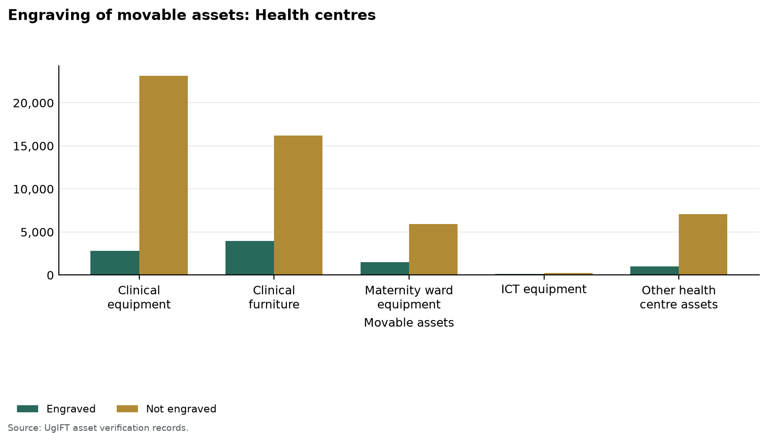
Figure 49: Engraving of movable assets: Health centres

Table 16: Identification of assets at Health centres
Asset category | Assets verified | Movable assets | Engraved | Properly engraved with UgIFT markings | Not engraved
Clinical equipment | 25,960 | 25,960 | 2,815 (10.8%) | 1,043 (4.0%) | 23,145 (89.2%)
Clinical furniture | 20,139 | 20,139 | 3,934 (19.5%) | 1,576 (7.8%) | 16,205 (80.5%)
Maternity ward equipment | 7,438 | 7,438 | 1,510 (20.3%) | 815 (11.0%) | 5,928 (79.7%)
ICT equipment | 410 | 410 | 155 (37.8%) | 133 (32.4%) | 255 (62.2%)
Health centre buildings | 1,525 | - | - | - | -
Other health centre assets | 8,124 | 8,124 | 1,032 (12.7%) | 250 (3.1%) | 7,092 (87.3%)
Land | 3 | - | - | - | -
Total | 63,599 | 62,071 | 9,446 (15.2%) | 3,817 (6.1%) | 52,625 (84.8%)

Financial Value of assets: The recorded value of assets at the health centres is/was UGX 259,662,759,164 and the net book value was UGX 218,378,252,366, while accumulated depreciation was UGX 41,291,769,808 as at 30 September 2026. Table 17 presents the recorded value and net book value.
Table 17: Recorded and net book values at Health centres
Asset category | Assets | Recorded value UGX | Depreciation UGX | Net book value UGX
Clinical equipment | 25,960 | 32,419,253,988 | 12,264,441,553 | 20,154,812,435
Clinical furniture | 20,139 | 16,115,597,625 | 6,920,036,277 | 9,202,824,358
Maternity ward equipment | 7,438 | 7,419,395,159 | 3,270,066,317 | 4,149,328,842
ICT equipment | 410 | 876,467,375 | 646,446,250 | 230,021,125
Health centre buildings | 1,525 | 198,198,049,954 | 17,166,034,514 | 181,032,015,440
Other health centre assets | 8,124 | 4,583,995,063 | 1,024,744,897 | 3,559,250,166
Land | 3 | 50,000,000 | 0 | 50,000,000
Total | 63,599 | 259,662,759,164 | 41,291,769,808 | 218,378,252,366
Recorded value is the cost in the verification records. Net book value is that cost less accumulated depreciation to 30 September 2026, and is not taken below zero.

Seed Secondary Schools

Availability of the assets
The findings showed that the Seed Secondary Schools received 145,376 assets covering the following categories; School buildings, Water facilities, School furniture, Computers and related equipment such as monitors, UPS units and keyboards, ICT equipment including; printers, photocopiers, cameras and projectors and other school assets such as laboratory items, electrical items, plant and machinery and sports equipment. Table 18 presents the details.

Table 18: Availability of assets at Seed Secondary Schools
Asset category | Assets verified | Share
School buildings | 4,341 | 3.0%
Water facilities | 594 | 0.4%
School furniture | 109,646 | 75.4%
Computers and related equipment | 10,266 | 7.1%
ICT equipment | 1,503 | 1.0%
Other school assets | 19,026 | 13.1%
Total | 145,376 | 100.0%

Asset condition and functionality

Out of 145,376 assets; 138,075 (95.0%) were in good condition. Of those in good condition, 137,585 were in use and 490 were in store. The verification further established that 2,722 (1.9%) were broken while 4,579 (3.1%) were not in use for other reasons. Table 19 indicates the Asset condition.

Table 19: Condition of assets: Seed secondary schools
Asset category | Assets verified | Good condition |  | Broken | Other
Asset category | Assets verified | In use | In store | Broken | Other
School buildings | 4,341 | 4,238 | 3 | 14 | 86
Water facilities | 594 | 560 | 0 | 15 | 19
School furniture | 109,646 | 104,233 | 0 | 2,455 | 2,958
Computers and related items | 10,266 | 8,777 | 301 | 208 | 980
ICT equipment | 1,503 | 1,395 | 30 | 11 | 67
Other school assets | 19,026 | 18,382 | 156 | 19 | 469
Total | 145,376 | 137,585 | 490 | 2,722 | 4,579
Good condition is assets in use plus assets in store. Broken assets are counted on their own, including broken assets found in store. Other assets are not in use for another reason. The four condition columns sum to assets verified

School furniture (desks, tables, chairs, shelves and stools) is the largest category with 109,646 assets. Of these, 104,233 were in good conditions and in use while 2,455 were broken. Computers and related equipment had 8,777 in use.

Asset marking and Identification

Of the 138,671 movable assets, 35,121 (25.3%) were engraved whereas 103,550 (74.7%) were not engraved. 14,861 (10.7%) carried the UgIFT markings and 20,260 (14.6%) carried other markings as shown in Table 20.

Table 20: Identification of assets at Seed Secondary Schools
Asset category | Assets verified | Movable assets | Engraved | Properly engraved | Not engraved
School buildings | 4,341 | - | - | - | -
Water facilities | 594 | 0 | 0 (0.0%) | 0 (0.0%) | 96(100.0%)
School furniture | 109,646 | 109,646 | 31,656 (28.9%) | 14,405 (13.1%) | 77,990 (71.1%)
Computers and related equipment | 10,266 | 10,059 | 2,445 (24.3%) | 310 (3.1%) | 7,614 (75.7%)
ICT equipment | 1,503 | 1,503 | 169 (11.2%) | 5 (0.3%) | 1,334 (88.8%)
Other school assets | 19,026 | 17,367 | 851 (4.9%) | 141 (0.8%) | 16,516 (95.1%)
Total | 145,376 | 138,671 | 35,121 (25.3%) | 14,861 (10.7%) | 103,550 (74.7%)
Movable assets exclude buildings, structures and land. Properly engraved means the asset has UgIFT marking. A dash means the assets are identified through property and site records rather than engraving.

3.7.4 Financial Value of assets

The recorded value is/ was UGX 678,247,549,426, the net book value is/ was UGX 576,704,905,370 and accumulated depreciation was UGX 101,549,907,057 as at 30 September 2026 as presented in Table 21.

Table 21: Recorded value and net book value for Seed secondary schools
Asset category | Assets | Recorded value UGX | Depreciation UGX | Net book value UGX
School buildings | 4,341 | 495,160,116,359 | 54,728,357,865 | 440,431,758,495
Water facilities | 594 | 3,076,630,427 | 817,399,552 | 2,259,230,875
School furniture | 109,646 | 94,322,583,307 | 18,004,437,908 | 76,325,408,399
Computers and related equipment | 10,266 | 25,434,940,136 | 13,385,662,572 | 12,049,277,564
ICT equipment | 1,503 | 3,790,186,812 | 2,174,847,712 | 1,615,339,100
Other school assets | 19,026 | 56,463,092,385 | 12,439,201,448 | 44,023,890,937
Total | 145,376 | 678,247,549,426 | 101,549,907,057 | 576,704,905,370
Recorded value is the cost in the verification records. Net book value is that cost less accumulated depreciation to 30 September 2026.

Completion Status of Facilities
The verification established that there were a number of facilities that were either completed or not completed. Table 27 provides the details.

Table 27: Program-list facilities verified, completed and providing services
Measure | Health centres | Seed schools | Total
Programme list | 371 | 258 | 629
Works completed | 320 (92.2%) | 155 (63.8%) | 475 (80.5%)
Works not completed | 27 (7.8%) | 88 (36.2%) | 115 (19.5%)
Counts are facilities. Verified and accounted for through reconciliation are percentages of the Program list; the other percentages are of verified facilities.

Table 27 indicates that works were completed at 475 of the verified facilities (80.5%) while works were not complete at 115 (19.5%). Eighty-eight schools (36.2%) were still under construction or not yet handed over by the contractor compared to 27 (7.8%) in case of health facilities.

The photos below depict some of the facilities that are complete
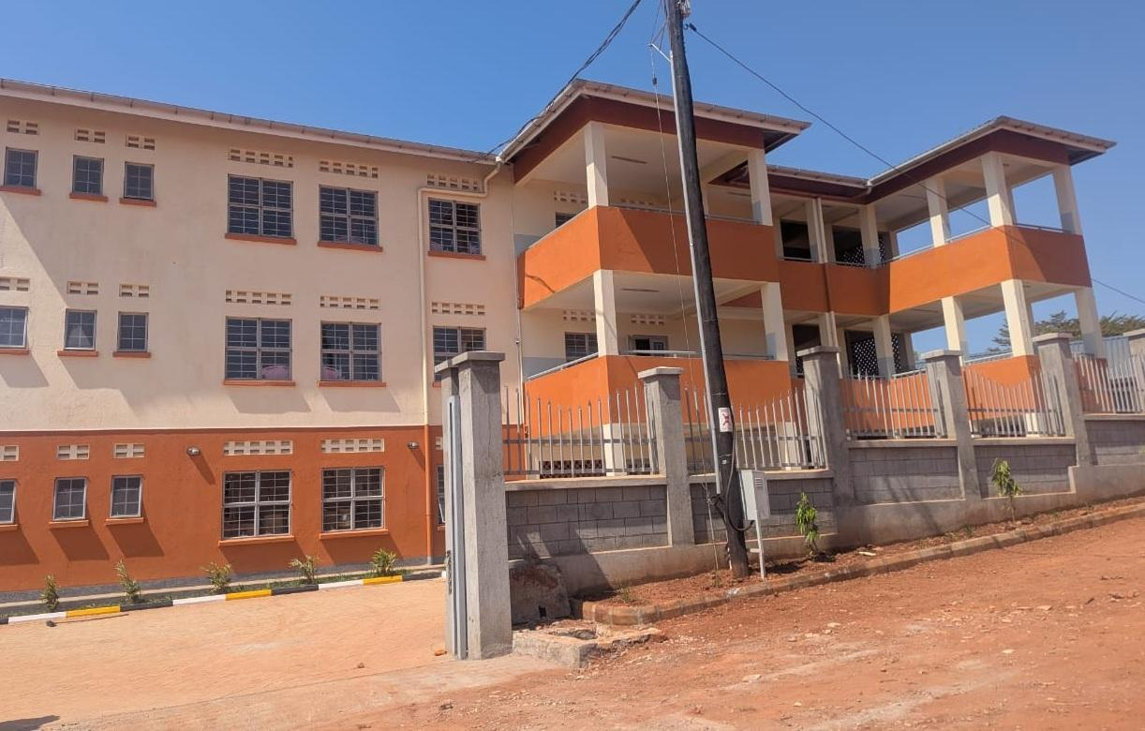  Figure 89: Health Centre building at Kibiri HC III, Makindye-Ssabagabo Municipal Council (Buganda) | 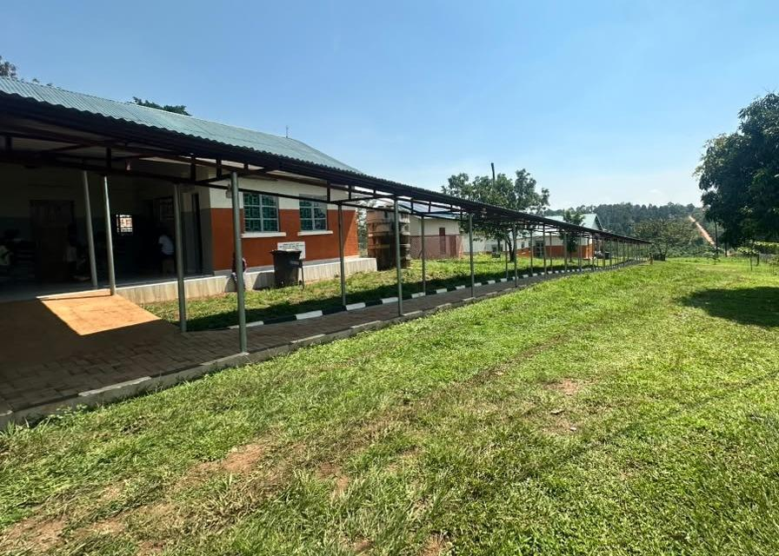  Figure 90: Health Centre buildings and covered walkway at Kihuukya HC III, Hoima City (Bunyoro)

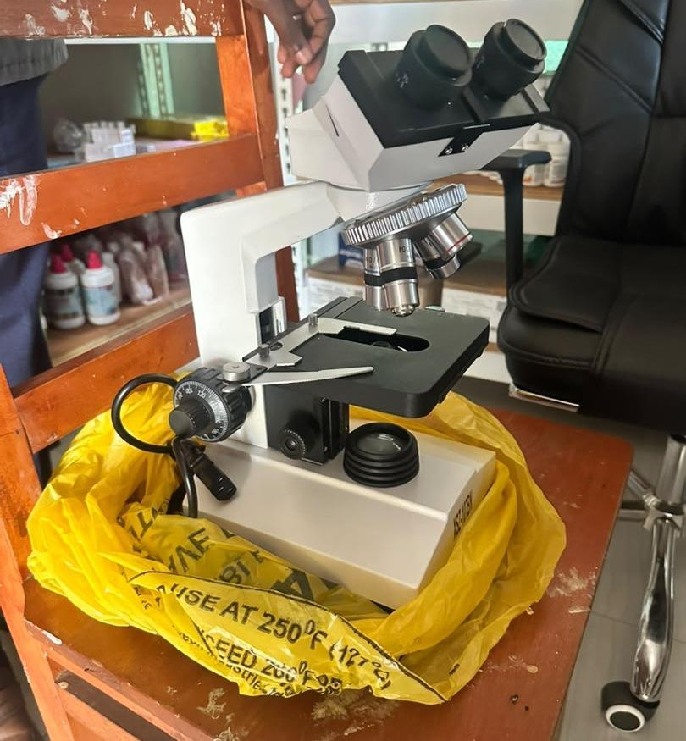  Figure 91: Binocular microscope at Kihuukya HC III, Hoima City (Bunyoro) |  |  | 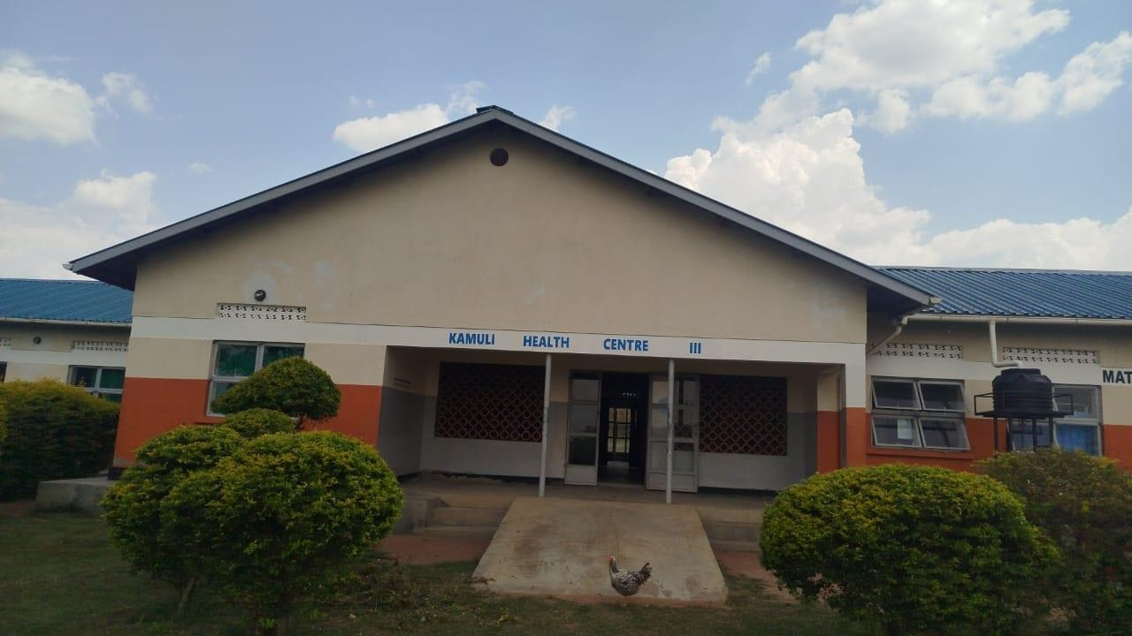  Figure 93: Maternity block entrance and access ramp at Kamuli HC III, Tororo District (Bukedi)
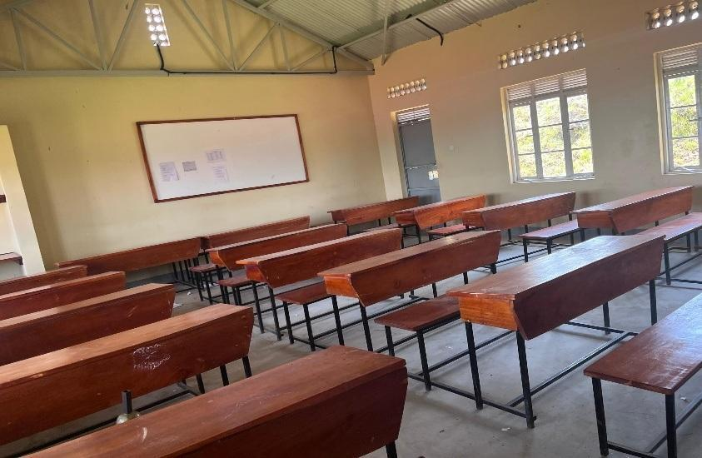  Figure 94: Classroom furnished with desks and a whiteboard at Gyagenda Memorial Seed Secondary School, Kalangala District (Buganda) |  | 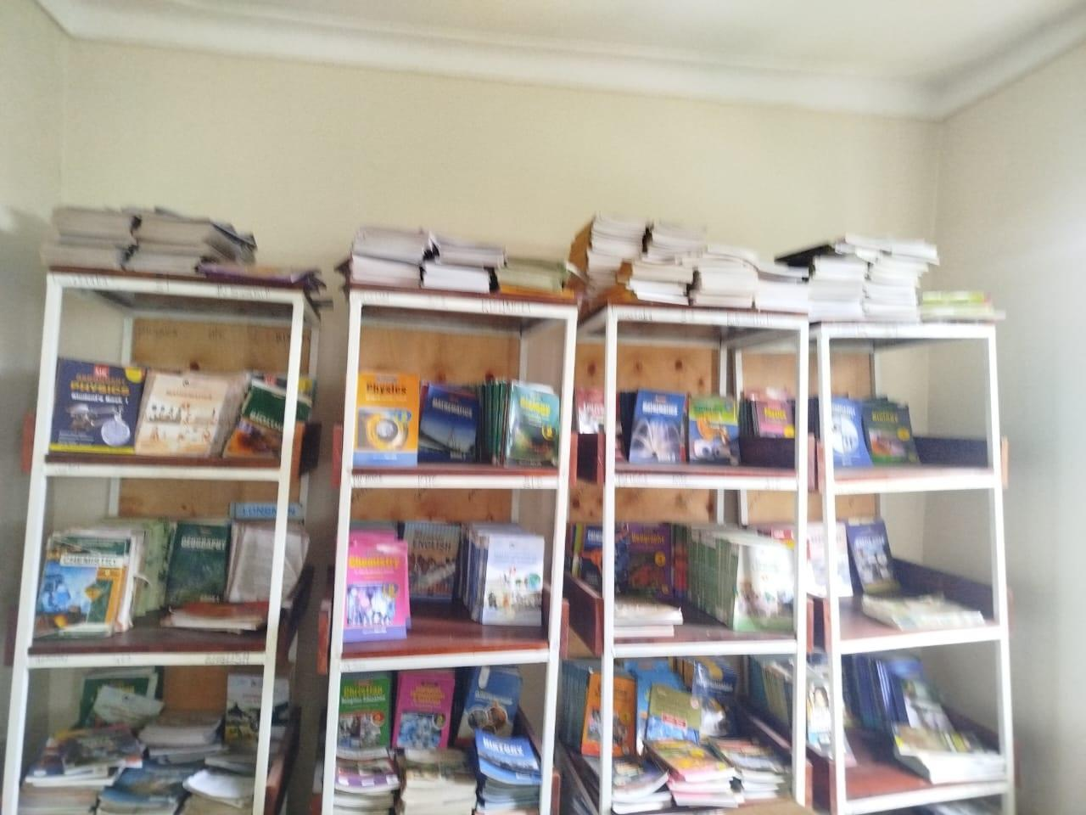  Figure 95: Books displayed on library shelves at Sibanga Seed School, Manafwa District (Bugisu) |  | 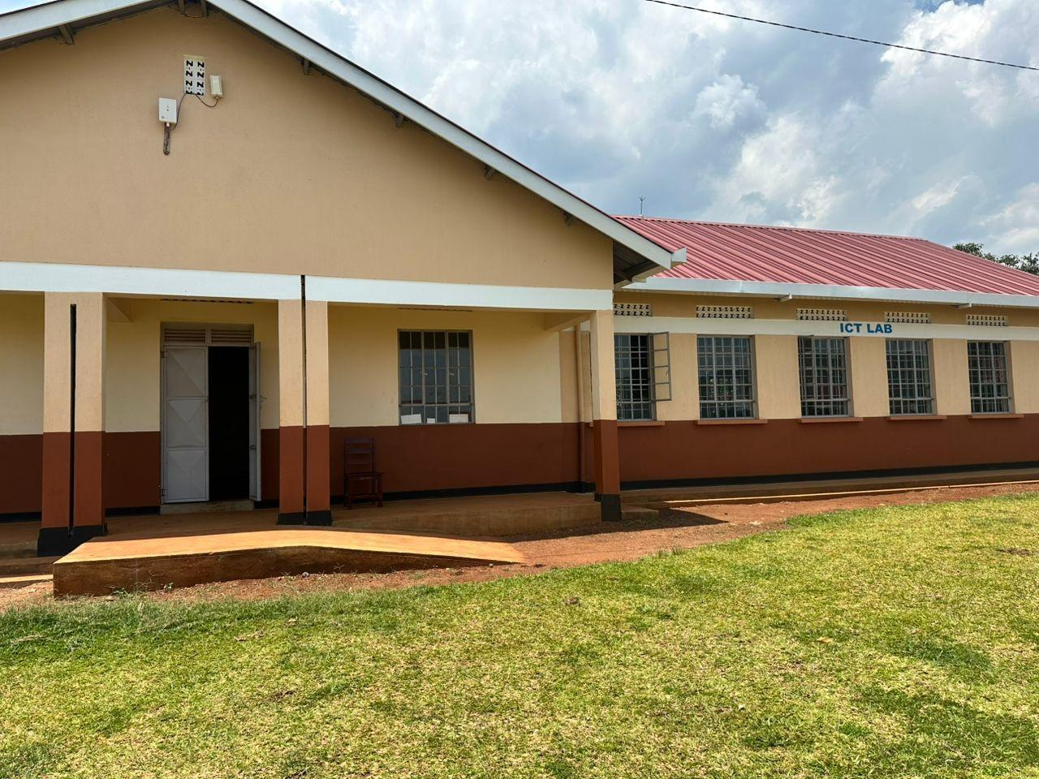  Figure 96: ICT laboratory block and entrance ramp at Sisiyi Seed Secondary School, Bulambuli District (Bugisu)

The photos below show some of the facilities that are still under construction
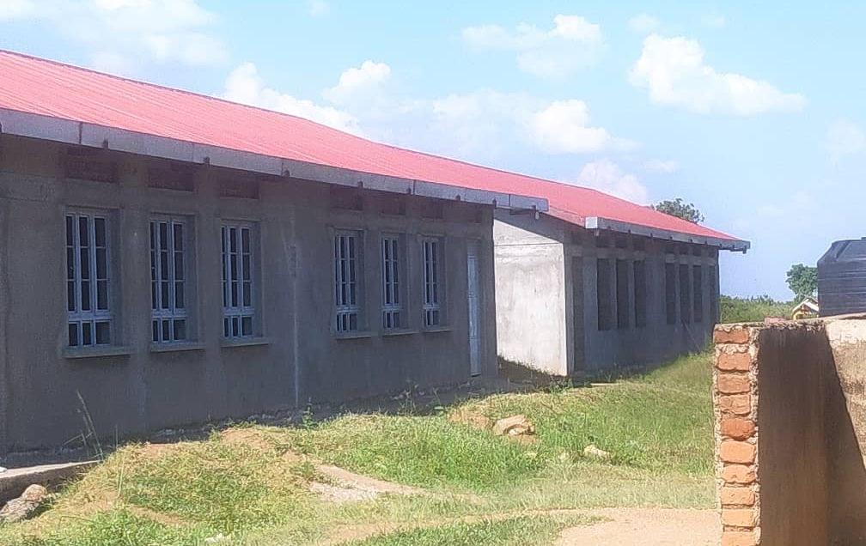  Figure 74: Unfinished school block at Got Apwoyo Seed Secondary School, Nwoya District (Acholi) | 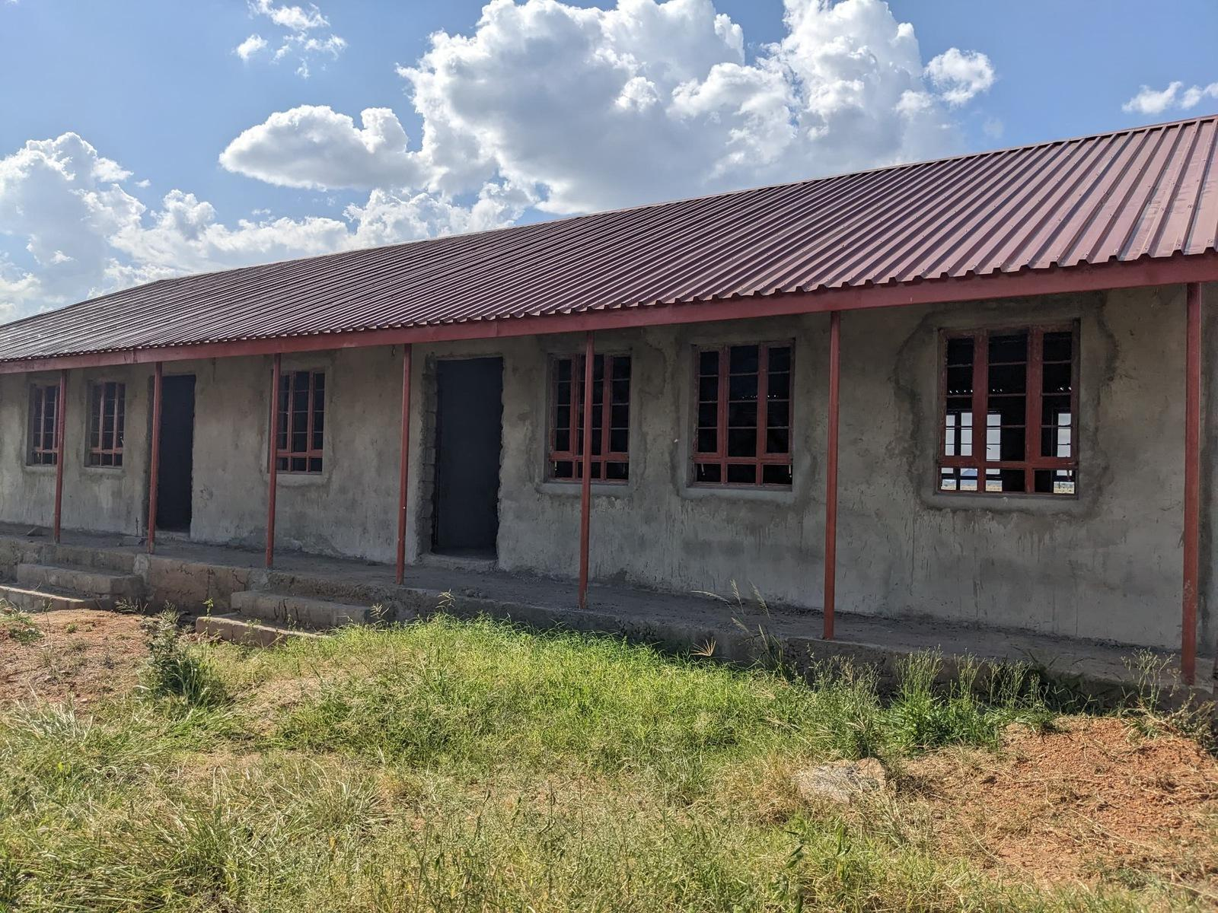  Figure 75: Unfinished classroom block at Sidok Seed Secondary School, Kaabong District (Karamoja)

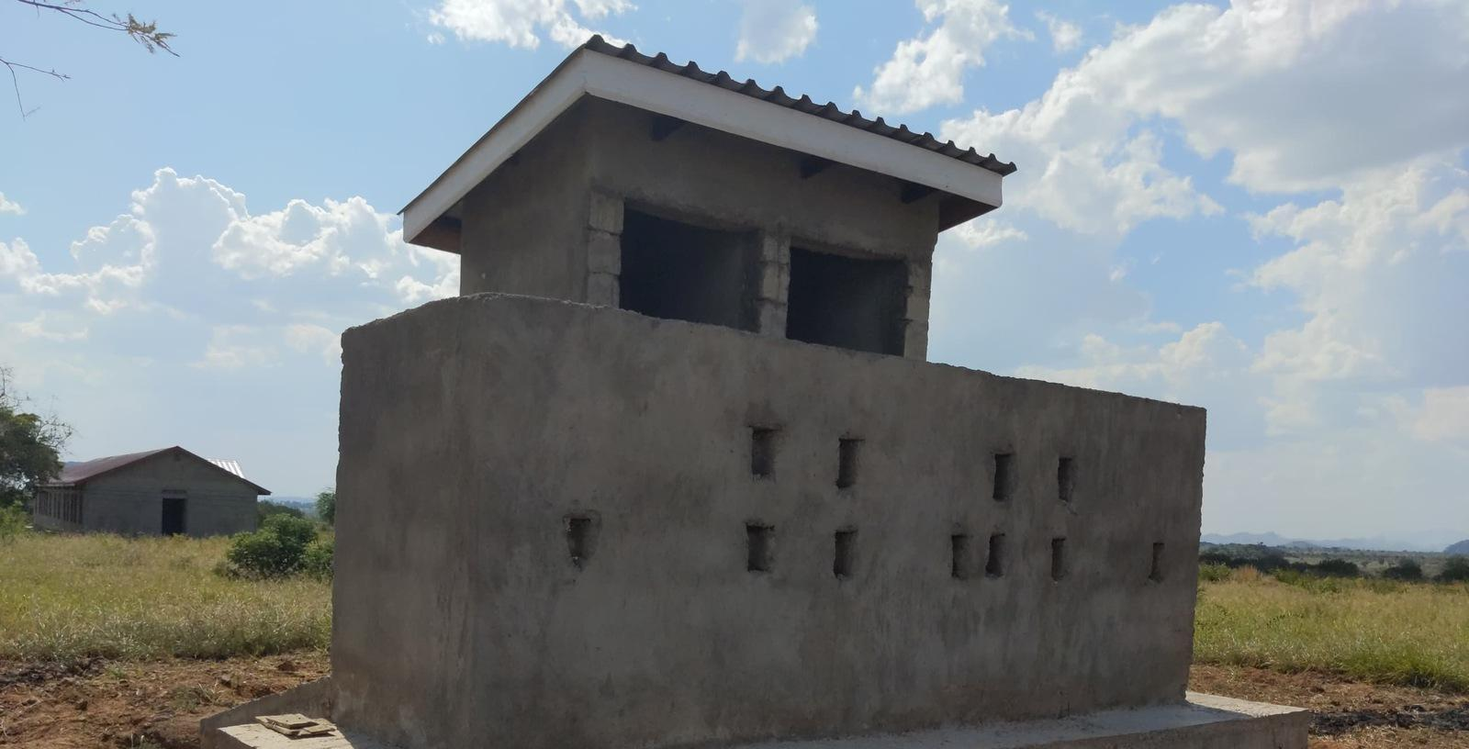  Figure 76: Latrine block under construction at Sidok Seed Secondary School, Kaabong District (Karamoja) | 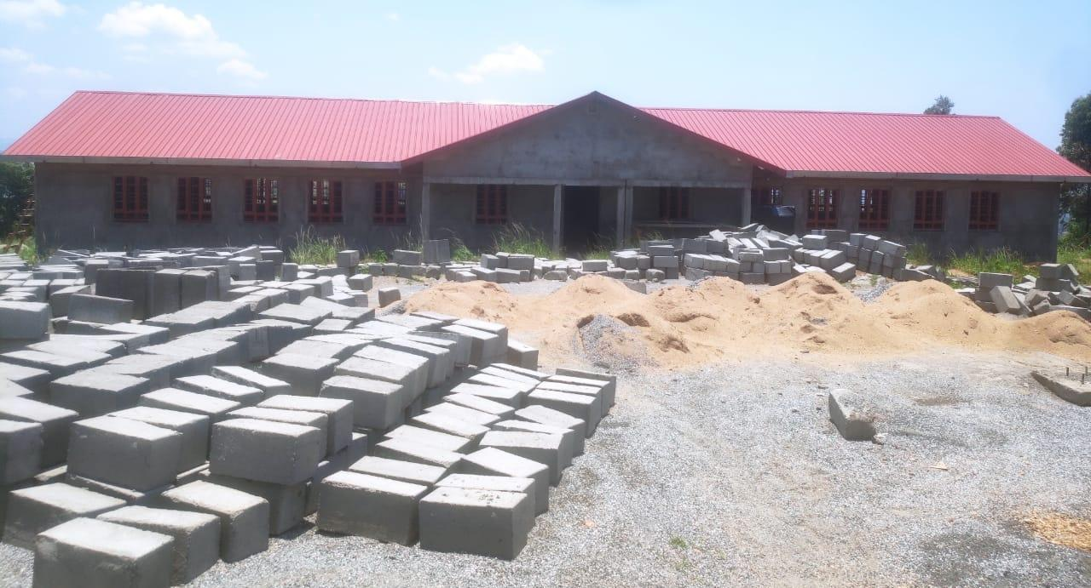  Figure 77: Building works and construction materials at Ndhew Seed Secondary School, Nebbi District (West Nile)

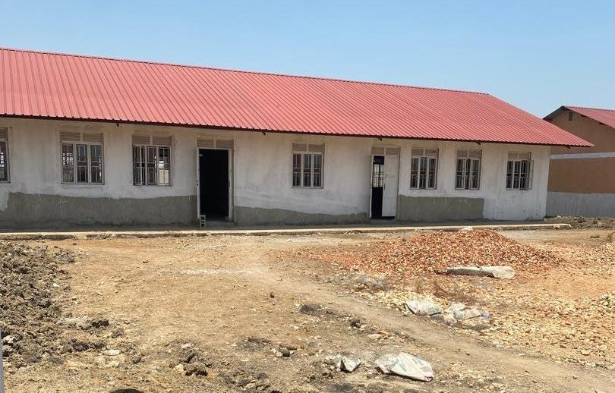  Figure 78: School block awaiting completion at Butungama Seed Secondary School, Ntoroko District (Tooro) | 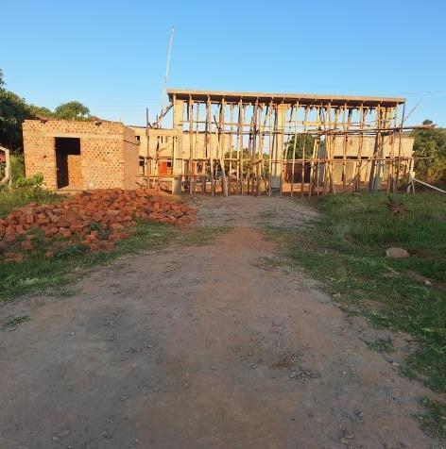  Figure 79: Building works at a seed secondary school, Kiboga District (Buganda) | 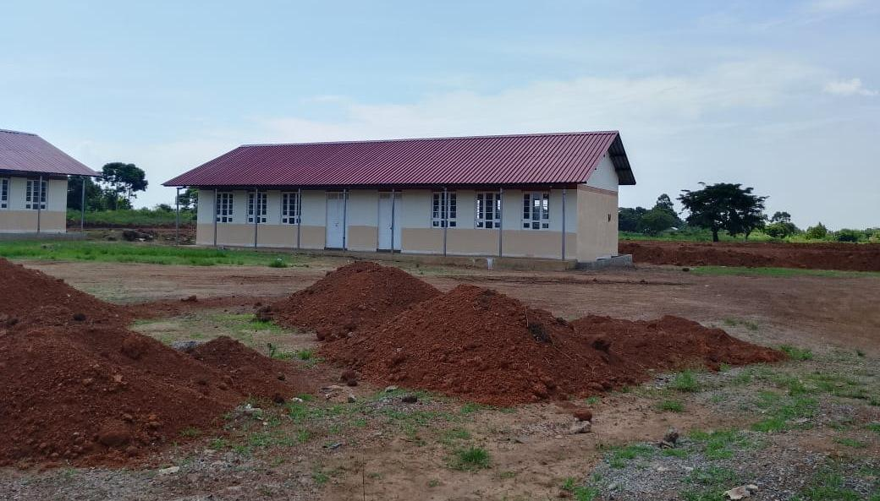  Figure 80: Classroom block with earthworks in the foreground at Kihungya Seed Secondary School, Buliisa District (Bunyoro)

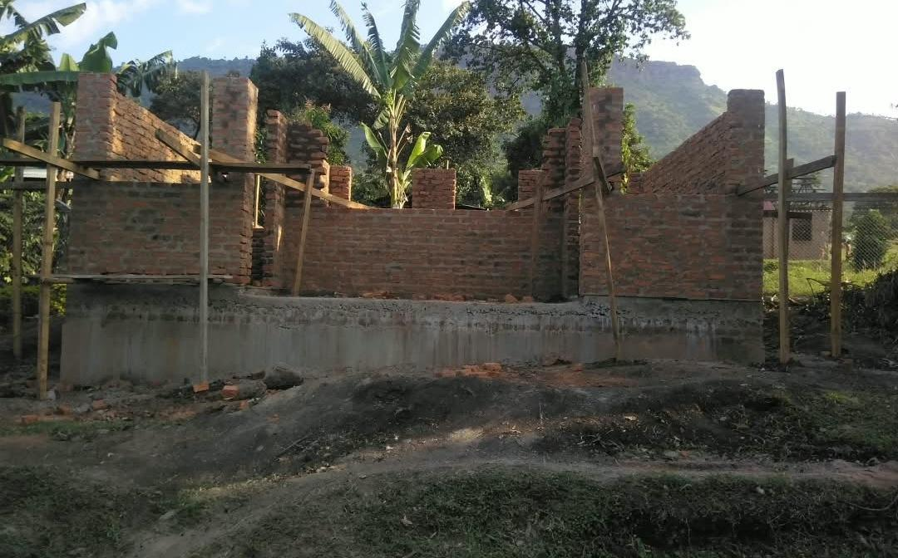  Figure 81: Unfinished laboratory building at a health centre in Sironko District (Bugisu) | 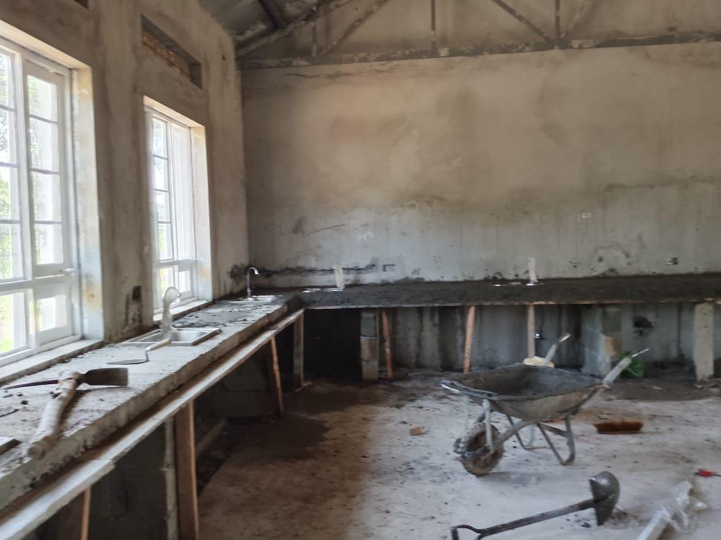  Figure 82: Biology laboratory under construction at a seed secondary school, Buliisa District (Bunyoro) | 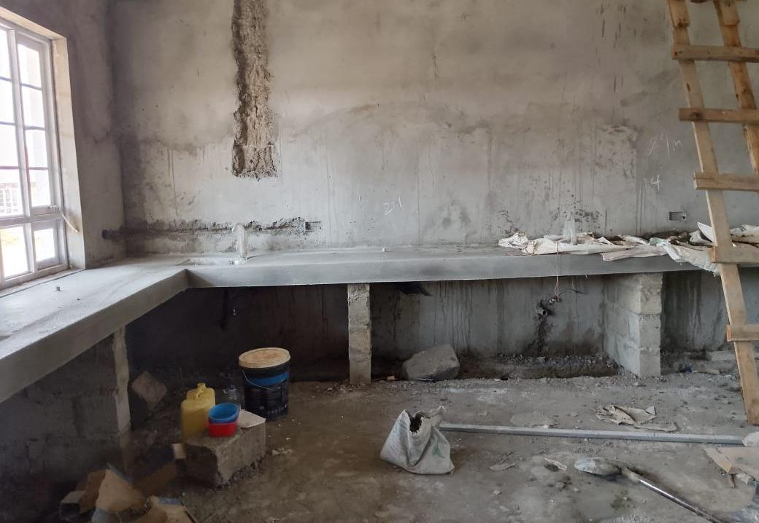  Figure 83: Unfinished laboratory interior at Kihungya Seed Secondary School, Buliisa District (Bunyoro)

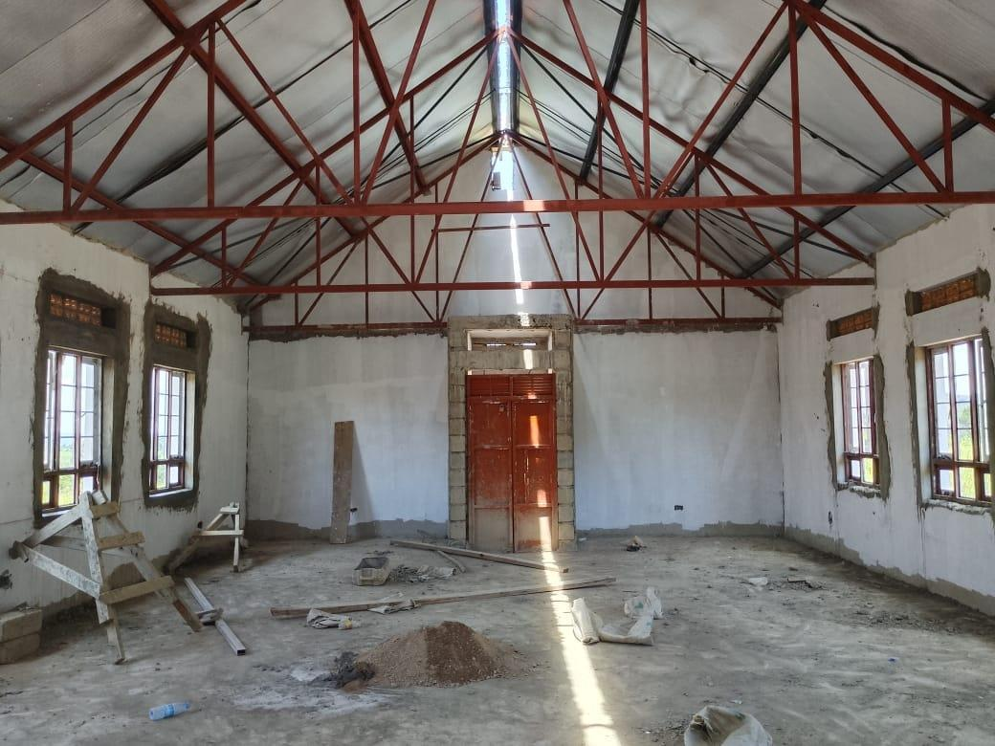  Figure 84: Library interior under construction at Kihungya Seed Secondary School, Buliisa District (Bunyoro) | 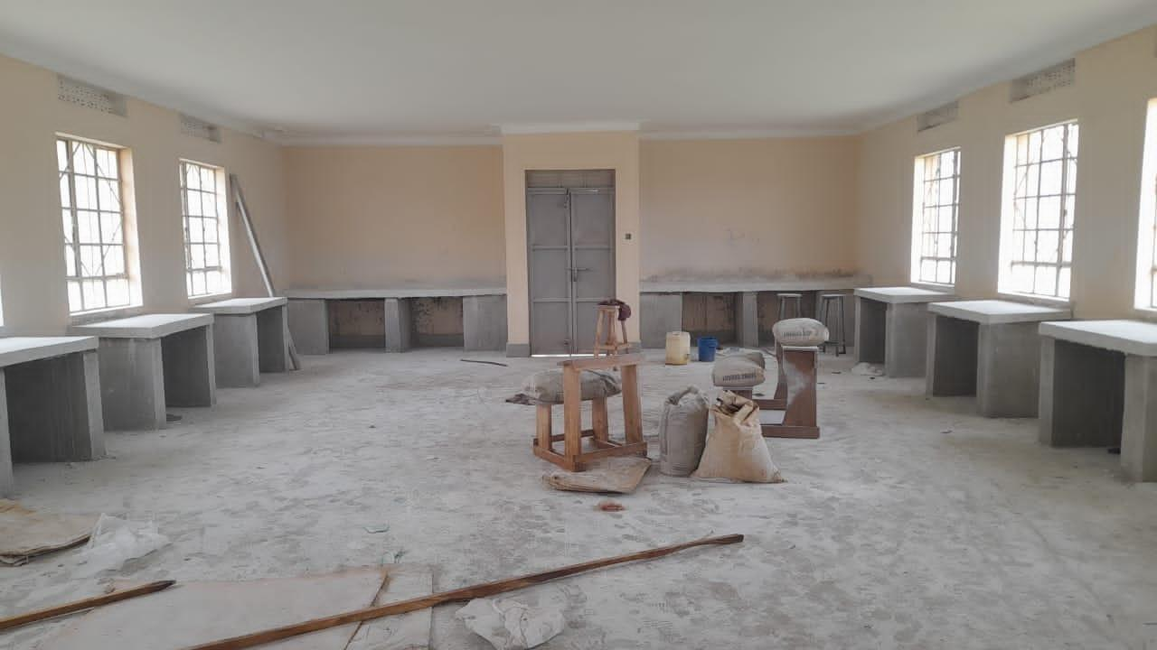  Figure 85: ICT laboratory interior under construction at Kitawoi Seed Secondary School, Kween District (Sebei)

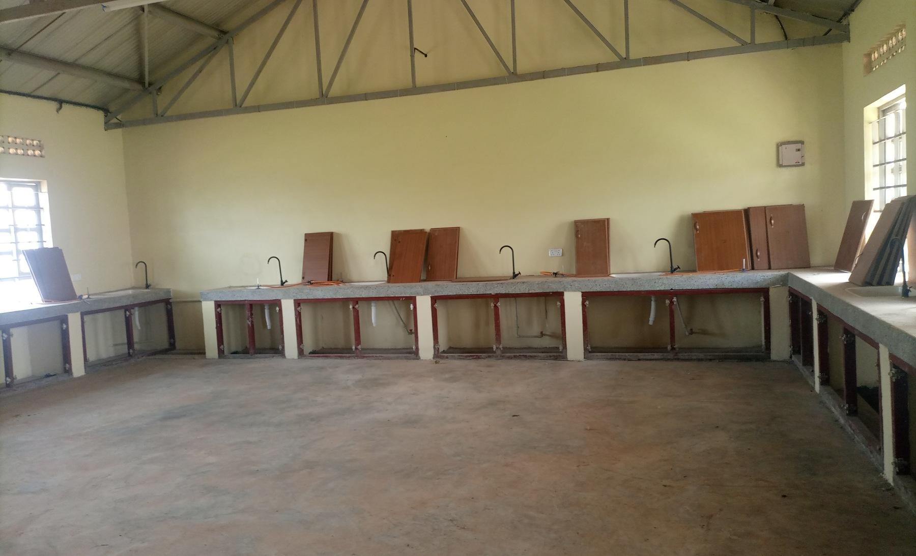  Figure 86: Laboratory benches with cupboard doors not yet fitted, in a science laboratory block recorded as under construction, at King Solomon Seed Secondary School, Kagadi District (Bunyoro) | 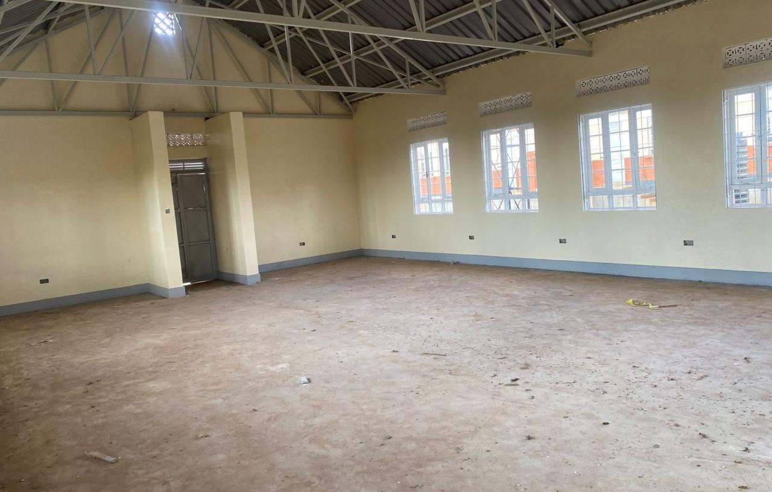  Figure 87: Empty computer laboratory at Kaptum Seed Secondary School, Kween District (Sebei), where the buildings had not been handed over and no ICT equipment had been received

Field Observations,

Location and Name changes
The verification exercise established that there were mismatches between information from the Program list and what was found on the ground. It was established that out of 629 facilities verified, 590 (93.8%) matched with the programme list as obtained from the MoFPED. A total of 39 facilities (6.2%) had inconsistencies with the programme list which included; i) operating under different names; ii) facilities found on the programme list but did not benefit from the programme; and iii) facilities that were found on ground to have benefited from the programme but were not included on the programme list. These inconsistencies were accounted for through reconciliation. Table 29 provides the details.

Table 29: Inconsistencies between the Programme list and the facilities on the ground
Outcome | Health centres | Seed schools | Total | Facilities (programme-list name and district: operating or receiving name)
Facilities on the programme list but not on ground | 7 | 3 | 10 | Health centres: Olok HC II (Pader); Alik HC II (Lira); Acimi HC II (Oyam); Acokara HC II (Oyam); Ariba HC II (Oyam); Busia Eastern Division (Busia Municipal Council); Butoloogo HC II (Kassanda)  Seed schools: Eastern Division (Tororo Municipal Council); Central Division (Jinja City); Kishangara Seed School (Ibanda)
Replaced by another facility | 4 | 0 | 4 | Health centres: Oweko HC II (Nebbi): Pamaka HC III; Loinya HC II (Maracha): Liko HC III, already on the programme list; Ngomoromo HC II (Lamwo): Pangira HC III; Musandama HC II (Ntoroko): Butungama HC III
Operates under another name | 10 | 20 | 30 | Health centres: Kocheka HC II (Bukedea): Kangole/Kocheka HC III; Dabani (Busia): Buwumba HC III; Mantoroba HC II (Bundibugyo): Busanga HC III; Kidubuli HC II (Kabarole): Iruhura HC III; Nyabuswa HC II (Kabarole): Nyambuusa HC III; Kabbo (Mubende): Nakawala HC III; Kikoola (Kakumiro): Mukoora HC III; Kyakatebe HC II (Kassanda): Namabaale HC III; Kagganda HC II (Lwengo): Mbirizi SSS; Bussi HC II (Wakiso): Zinga HC III, already on the programme list  Seed schools: Kadungulu Seed School (Serere) for Kagwara SSS; Pallisa (Pallisa) for Akadot SSS; Bunambutye Seed School (Bulambuli) for Bumufuni SSS; Igombe (Bugweri) for Mpiita SSS; Butagaya (Jinja) for Buwala SSS; Mwema Seed School (Namayingo) for Mutumba SSS; Kimenyedde Seed School (Mukono) for St Andrews Ndwaddemutwe SSS; Nsiika T/C (Buhweju) for Ndibarema Memorial SSS; Kagadi (Kagadi) for King Solomon SSS; Kiryanga Seed School (Kagadi) for St Catherine Kicucura SSS; Ruteete (Kagadi) for Kitegwa Community SSS; Kasenda Seed School (Kabarole) for St Paul Nyabweya SSS; Kabonero (Bunyangabu) for Katugunda SSS; Kyamukube Town Council (Bunyangabu): Nsuura SSS; Bufumira Seed School (Kalangala): Nekemiya Memorial SSS; Kiringente Seed School (Mpigi): Wamatovu SSS; Mpumudde Seed School (Lyantonde): Rwamabara SSS; Buhanika (Hoima): Kidukuru SSS; Maddu Seed School (Gomba): return submitted as Kyayi Seed School; Mugarama, new facilities for St Mugagga (Kibaale): St Mugagga Vocational SSS
Not a UgIFT beneficiary | 2 | 1 | 3 | Health centres: Alira HC II (Oyam); Buyinda HC II (Kaliro)  Seed schools: Kiziranfumbi Seed School (Kikuube)
UgIFT assets relocated to another facility | 2 | 1 | 3 | Health centres: Alangi (Zombo) to Amwonyo HC III; Ther-uru HC II (Zombo) to Atyak HC III  Seed schools: Abanga (Zombo) to Kango SSS
Exists with no UgIFT assets | 2 | 3 | 5 | Health centres: Pandwong HC II (Kitgum Municipal Council); Rwamujojo HC II (Sheema Municipal Council)  Seed schools: Bumbaire Seed School (Bushenyi); Kyamuhunga (Bushenyi); Kashenshero (Mitooma)
Counts are programme-list facilities. HC means health centre; SSS means Seed Secondary School.

3.7 UgIFT support to service delivery
Of the 284 health centres, 237 (83.5%) reported at least one benefit from the UgIFT support. Improved maternity and delivery services were reported by 117 (41.2%), and 51 (18.0%) reported more or safer births at the facility. Improved antenatal, immunisation, laboratory or other specific services were reported by 89 (31.3%), improved access to care or shorter distances by 70 (24.6%) and more patients attending by 60 (21.1%). More than half, 163 (57.4%), linked better services to the equipment and furniture supplied.
Of the 193 seed schools, 144 (74.6%) reported at least one benefit. A better learning environment, with classrooms, furniture and libraries, was reported by 74 (38.3%), and improved access to secondary education or shorter distances by 59 (30.6%). Practical science or ICT teaching improved at 39 schools (20.2%), and 37 (19.2%) reported higher enrolment. Forty schools (20.7%) also reported jobs and local economic benefits around the school. Figure 88 compares the benefits most reported on by the two types of facilities
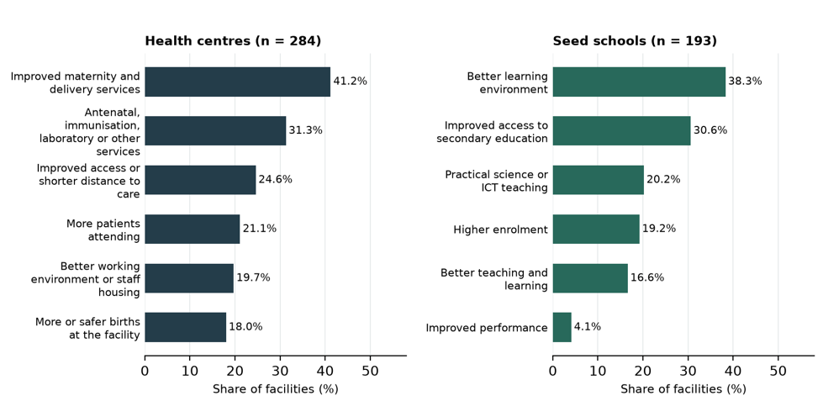
Figure 88: Program Benefits

3.7.2 Gaps and Challenges
The main gaps identified by the facilities include:
- Insufficient Power supply which was reported by 200 facilities of which 44.0% were health centres and 38.9% were schools;
- Inadequate Staffing which was reported by 32.3% of the facilities;
- Inadequate space or infrastructure reported by 31.7% of the facilities;
- Insecurity or absence of fencing reported by 27.3% of the facilities;
- Limited maintenance support was raised by 22.2% of the facilities;
- Inadequate staff houses reported by 22.0% of the facilities;
- Poor water supply reported by 20.1% of the facilities;
- Inadequate training of staff to operate the equipment reported by 28.9% of the health centres;
- Incomplete or delayed works reported by 28.0% of seed schools;
- Equipment not installed, not assembled or delivered incomplete was raised by 17.6% of the facilities;

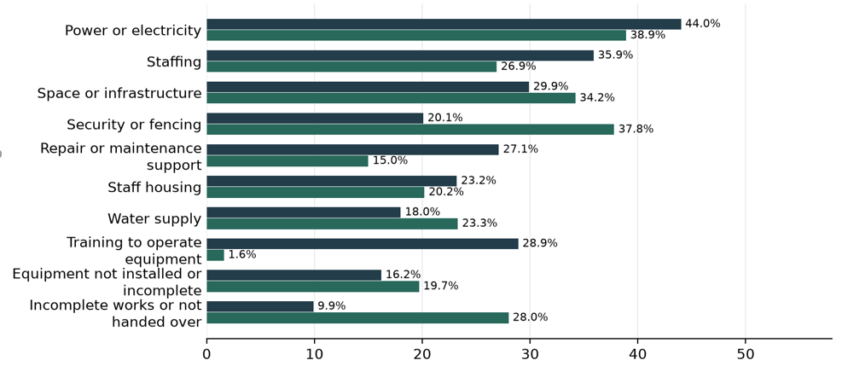
Figure 97: Service gaps and challenges

Asset management

Maintenance and repairs
Maintenance keeps UgIFT assets working for the services they were bought to support. Most of the verified assets are furniture, clinical equipment and computers in daily use at health centres and seed schools, where wear and breakage are to be expected. Routine checks, a record of faults and a dependable route for repair decide whether a broken item returns to use quickly or stays out of service. During the verification, each facility was asked how it maintains, repairs, services or replaces UgIFT assets and whether it keeps a regular record of their functionality or breakdown.
Repair arrangements. Of the 469 facilities that described their maintenance arrangements, 260 (55.4%) undertook repairs at facility level, from their own funds. i.e. Primary Health Care funds were used at Health Centres (94 of 278, 33.8%), while schools used the capitation or Universal Secondary Education grant, parents' contributions or the school budget (52 of 191, 27.2%). Busaale Health Centre III in Kayunga used Primary Health Care funds for repairs, and Kagumba Seed Secondary School in Kamuli repaired broken furniture during the second term using ……………... Some facilities undertook repairs using more than one arrangement.
Support from outside the facility was cited by 151 facilities (32.2%): district offices, mainly the District Health Officer, 84 (17.9%); regional referral hospital workshops or national teams 52 (11.1%); hired technicians and artisans 27 (5.8%); and contractors or suppliers under defects liability, guarantee or warranty 12 (2.6%). Major medical equipment repairs depended on this support. Todora Health Centre III in Nwoya worked with the District Health Officer and the Gulu Regional Referral Hospital technical team to undertake repairs, Avogera Health Centre III in Buliisa received support from Hoima Regional Referral Hospital, and Bundimulangya Health Centre III in Bundibugyo was supported by a team working with the District Health Officer.
In all, 97 facilities (20.7%), 59 of them schools, had not yet undertaken any maintenance because the assets were new, not yet handed over or the buildings were still under construction, and 36 (7.7%) reported no repair arrangement, with broken items set aside or not repaired. Funds for maintenance and repair were reported as insufficient, particularly for major repairs by 32 of the 505 facilities that described maintenance or challenges (6.3%). At Kyankaramata Health Centre III in Kyenjojo, Primary Health Care funds were used for minor repairs, but the cost of major repairs was a constraint.
Figure 98 compares these arrangements at health centres and seed schools. Health centres relied more on outside technical support (41.0% of health centres against 19.4% of schools), while schools were not yet in need of maintenance (30.9% against 13.7%).
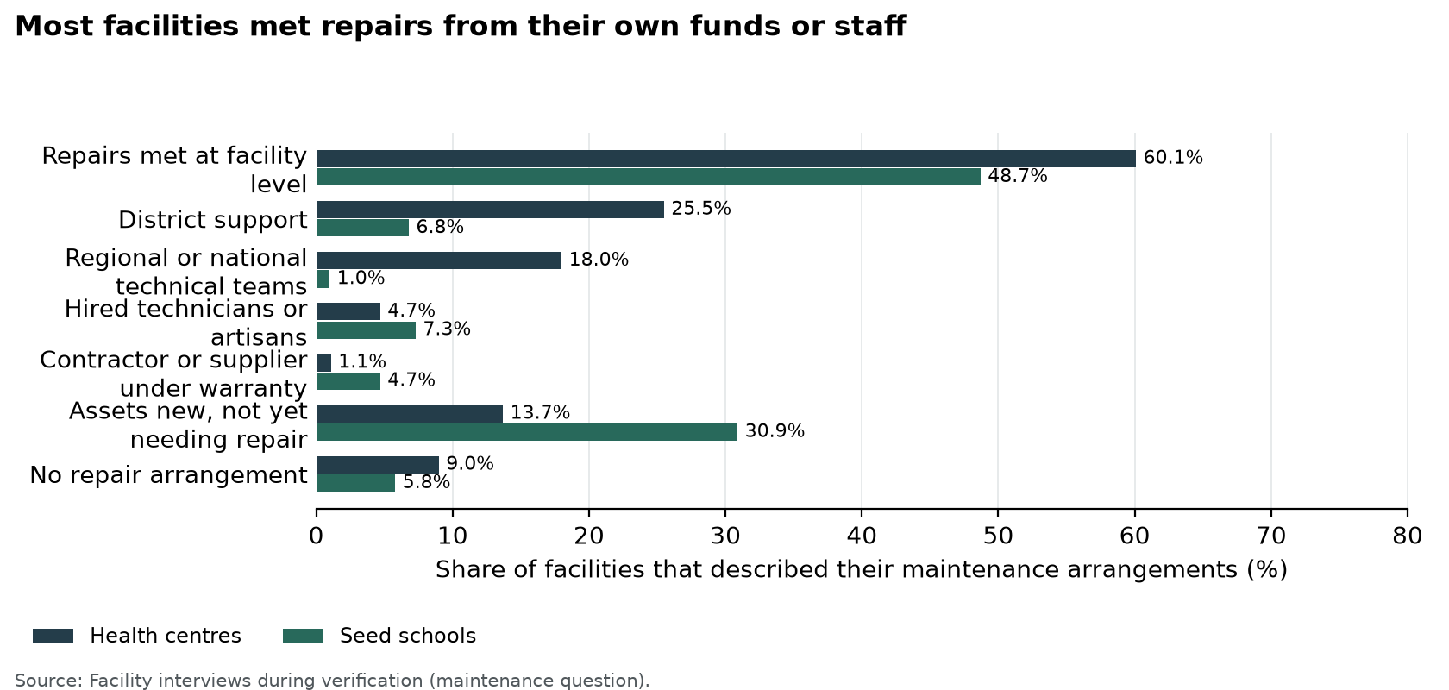
Figure 98: Most facilities met repairs from their own funds or staff
Frequency. Few facilities had a fixed maintenance interval. Of the 494 facilities on the programme- that described how they maintain UgIFT assets or check their condition, 50 (10.1%) did so at a fixed interval. Of these 50, 14 (28.0%) worked annually, 11 (22.0%) monthly, 10 (20.0%) quarterly, 9 (18.0%) every school term, 3 (6.0%) twice a year and 3 (6.0%) weekly or daily, as captured in Figure 99 . A further 18 facilities (3.6%) described routine or scheduled servicing without a set interval, mostly scheduled visits by regional referral hospital maintenance teams, and 62 (12.6%) repaired items as the need arose. Ngwedo Seed Secondary School in Buliisa engaged a caretaker every month and used the Directorate of Industrial Training for furniture repairs, while Busaale reviewed asset condition every quarter.
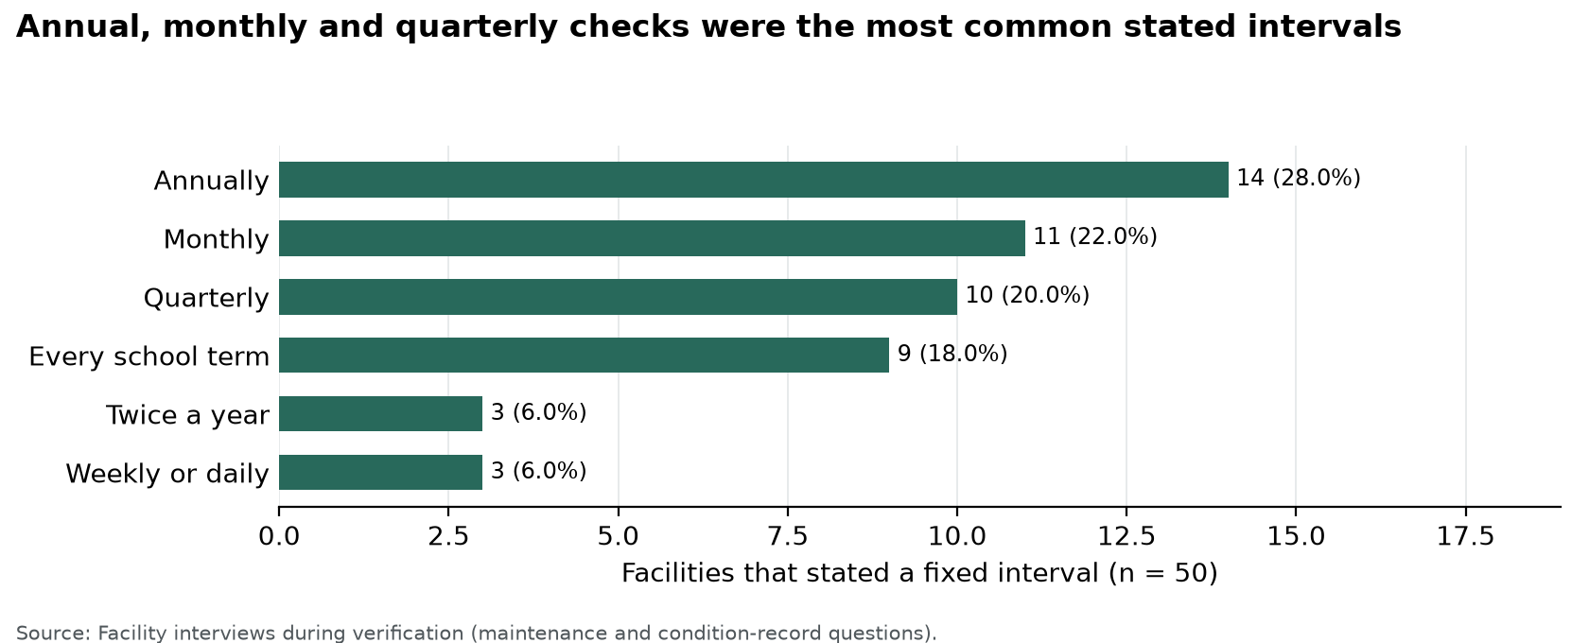
Figure 99: Annual, monthly and quarterly checks were the most common stated intervals
Records. Of the 463 facilities that answered, 318 (68.7%) kept a regular record of asset functionality or breakdowns, 36 (7.8%) kept a partial or informal record, 80 (17.3%) kept none and 29 (6.3%) had not yet started because the assets were new or the facility was not yet operational. Of the 478 facilities that answered, 355 (74.3%) had a record of the UgIFT assets they received, 40 (8.4%) had a partial record, such as delivery notes only or a general register that does not identify UgIFT items, and 83 (17.4%) had none. Kagumba Health Centre III in Kamuli kept an asset condition book, a simple practice that other facilities can adopt.

Recommendations

Recommendation. Facility managers and school governing bodies should keep the local and regional repair arrangements that already work and adopt a fixed routine: a condition check at least every school term in schools and every quarter in health centres, and a full count of UgIFT assets each year should be undertaken. Each facility should keep a condition book or fault list naming each item requiring action, the responsible person and the agreed completion date; the 36 facilities with no repair arrangement and the 80 with no functionality or breakdown record should set these up first.
District health and education offices should review unresolved repairs each quarter and arrange technical assistance, and regional referral hospital workshops should include UgIFT equipment in their scheduled visits. Annual maintenance plans should separate minor repairs from major repairs such that the minor repairs be met from Primary Health Care funds or school grants, while major repairs can be handled through district or national funding.
Recommendation. Facility managers, district health and education officers, engineers and technical teams should address issues of unsafe furniture, electrical concerns and failed equipment as a priority. The broken down and non functional assets should be assessed in order of their effect on care and teaching, beginning with clinical equipment and the school furniture that makes up most of the broken down assets; items beyond economic repair should receive a formal disposal decision. At national level, the Office of the Prime Minister should decide on repair or replacement of its three damaged laptops, and Uganda Blood Transfusion Services (UBTS) should repair or replace the six broken blood pressure machines at Arua Regional Blood Bank.
Keep damaged assets separate from usable assets awaiting installation so that each receives the appropriate action.
Recommendation. LG Accounting Officers, engineers, and contractors should develop site-specific completion plans for each of the 115 facilities with outstanding works.
Installation should follow confirmation that rooms, power, water and security are ready. Stored assets described as new or in good condition should be installed in the appropriate rooms and each asset waiting for power or installation should have a named date for connection, testing and signing off before handover or closing each action. .
Protect services already operating during construction.
Recommendation. District health officers, facility managers, suppliers and regional technical teams should provide practical training for staff who need to use specialised equipment. Health centres that linked idle equipment to lack of skills should be prioritised.
At handover, facility in-charges and staff should be given a demonstration, basic maintenance guidance and a named route for technical support. Future supply contracts should make on-site demonstration to the staff who will use the equipment.
a condition of acceptance and staffing reviews should take account of the equipment each health centre now holds.
Recommendation. Institution asset managers and LG finance, health and education officers should engrave all the verified assets with UgIFT markings and confirm their locations and custodians. Assets carrying other markings should receive the UgIFT Program identifier at their next check.
Resolve the allocation of equipment with signed transfer or receipt documentation. Also deliver assets held at district stores to the appropriate facilities once buildings are complete and ready. Furthermore delivery of the items that are still with suppliers should be completed
The Ministry of Works and Transport should retain the completed tracing record and keep the confirmed custodians and locations current. Losses should be reported and investigated under the public finance rules, and every facility should have a list of the UgIFT assets it received, showing each item, its engraving and its custodian.
Maintain site, ownership and handover records for buildings and land.
Recommendation. The Ministry of Finance, Planning and Economic Development, Ministry of Health the Ministry of Education and Sports should approve a corrected Program list after rectifying the inconsistencies.

Annexures

Let us have a list of Annexes even if the annexes are not yet appended to the report.

UgIFT Programme provided assets to other national and subnational agencies that were not directly involved in implementation such as KCCA, MODVA, hospitals and health centres across the country
Movable assets exclude buildings, structures and land. Properly engraved means the UgIFT marking has been used.

